BRICE PRAIRIE CONSERVATION ASSOCIATION

Over Twenty Years of Helping Our Local Waterfowl

Wood Duck and Hooded Merganser Report

2008

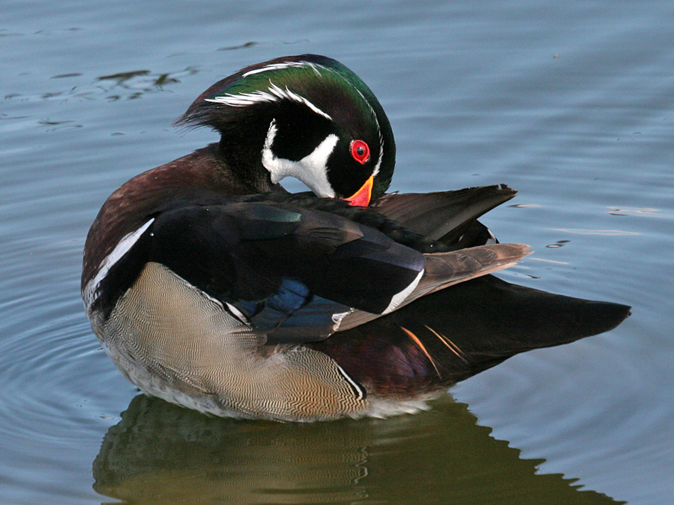
arnica.csustan.edu

BY

JOHN WETZEL AND MARC SCHULTZ

WWW.BRICEPRAIRIECONSERVATION.ORG

ONALASKA, WISCONSIN

BRICE PRAIRIE CONSERVATION ASSOCIATION

WOOD DUCK AND HOODED MERGANSER REOORT

2008

OVER TWENTY YEARS OF HELPING OUR LOCAL WATERFOWL

This report represents the twenty-first year that members of the Brice Prairie Conservation Association have monitored wood duck boxes and reported on results. This year 16 members and Boy Scout Troop 21 assisted in monitoring 413 boxes of which 192 or 46 percent were used (Table 1).

Fifty-three of these boxes were used by wood ducks (Table 2). Eighty-seven percent or 46 of the boxes hatched one or more wood duck ducklings that left the box. Of the 660 wood duck eggs laid, 555 ducklings were produced which is our best wood duck production since 2005 (Table 4).

Our hooded merganser production also increased over 2006 and 2007, as 1,061 hatchlings were found in 2008 from 103 boxes that had at least one egg hatch (Tables 3 & 4).

In our twenty-first year, BPCA has reached a real milestone as almost 25,000 wood duck and hooded merganser ducklings have been produced in our boxes! This includes almost 9,400 wood ducks and over 15,600 hooded mergansers (Table 4).

The BPCA also sells wood duck and blue bird boxes. If you are interested in purchasing a box and helping wildlife, please check our website and contact a Board member.

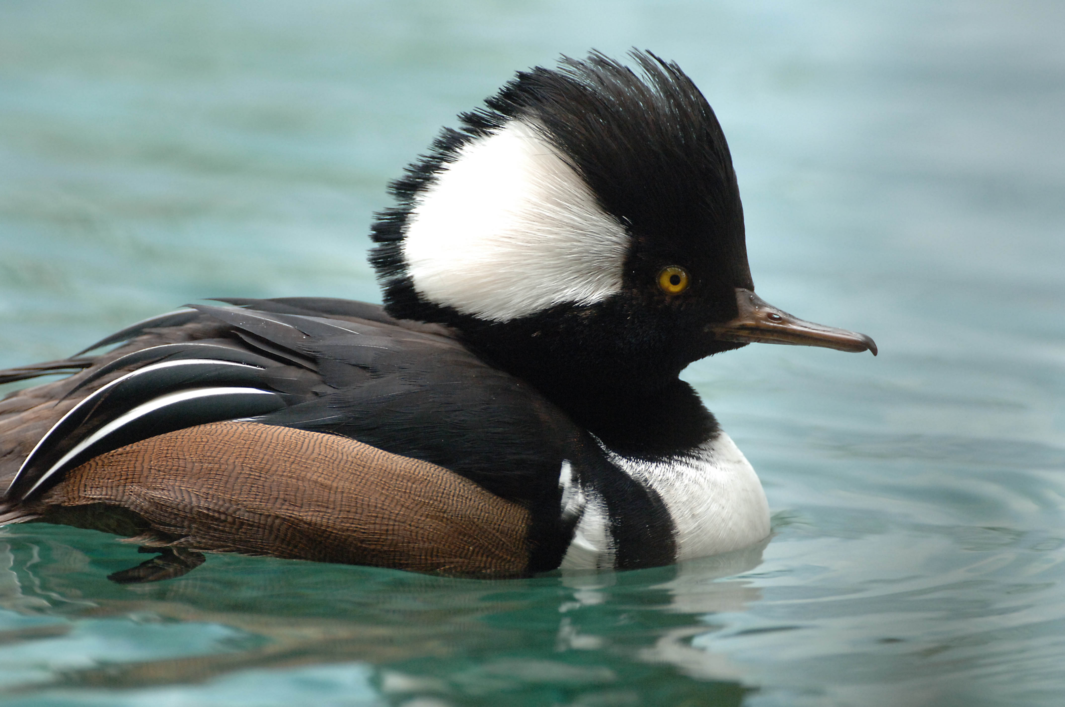

www.dnr.state.oh.us/

BRICE PRAIRIE CONSERVATION ASSOCIATION
2008

TABLE 1: TOTAL WOOD DUCK BOXES – AVAILABLE AND USED

 |  | Boxes %
Name | Location | Avail. | Used | Used
Ben Breidenbach | Black R. - Hunter’s Bridge | 5 | 3 | 60
Fred Craig | Sunset Farms | 6 | 3 | 50
Al Daus | Lake Onalaska Dike | 7 | 4 | 57
Greg Egan | Dakota, MN | 17 | 9 | 53
Jerry Guentz | La Crosse River | 7 | 7 | 100
Rick Knuth | Chipmunk Coulee Cr. | 13 | 7 | 54
Mike Lanquist | BP/Marges’ Dikes | 5 | 4 | 80
Amanda Marco | Girl Scout Camp | 15 | 8 | 53
Dick Marco | Browns Marsh | 15 | 8 | 53
Greg Marco | Eleva | 64 | 11 | 17
Leif Marking | French Is./Gills C./BP | 67 | 34 | 51
Jim Nissen | Upper Miss. Refuge – MN | 43 | 25 | 58
Marc Schultz/JW | Upper Lake Onalaska | 83 | 31 | 37
Ben Tippetts | Katie’s Slough | 6 | 3 | 50
Leif Tolokken | French Slough/ Buffalo Co. | 16 | 13 | 81
Troop 21 | Bike Trail – Tremp. End | 26 | 11 | 42
John Wetzel | Van Loon/ S. of Tremp. | 18 | 11 | 61
Totals |  | 413 | 192 | 46
BRICE PRAIRIE CONSERVATION ASSOCIATION
2008
TABLE 2: WOOD DUCK PRODUCTION

 | Nests % |  |  |  | Eggs %
Name | Attempts | Hatched | Hatched |  | Laid | Hatched* | Hatched
Ben Breidenbach | 3 | 3 | 100 |  | 27 | 22 | 81
Fred Craig | 2 | 1 | 50 |  | 17 | 15 | 88
Greg Egan | 3 | 3 | 100 |  | 35 | 35 | 100
Jerry Guentz | 1 | 1 | 100 |  | 2 | 2 | 100
Rick Knuth | 7 | 6 | 86 |  | 125 | 112 | 90
Mike Lanquist | 2 | 2 | 100 |  | 14 | 14 | 100
Amanda Marco | 1 | 1 | 100 |  | 9 | 9 | 100
Greg Marco | 10 | 8 | 80 |  | 121 | 116 | 96
Leif Marking | 12 | 11 | 92 |  | 187 | 158 | 84
Jim Nissen | 1 | 1 | 100 |  | 12 | 11 | 92
Leif Tolokken | 2 | 2 | 100 |  | 24 | 22 | 92
Troop 21 | 7 | 6 | 86 |  | 72 | 28 | 39
John Wetzel | 2 | 1 | 50 |  | 15 | 11 | 73
Totals | 53 | 46 | 87 |  | 660 | 555 | 84

* Hatched and Left Box (Ducklings Produced)

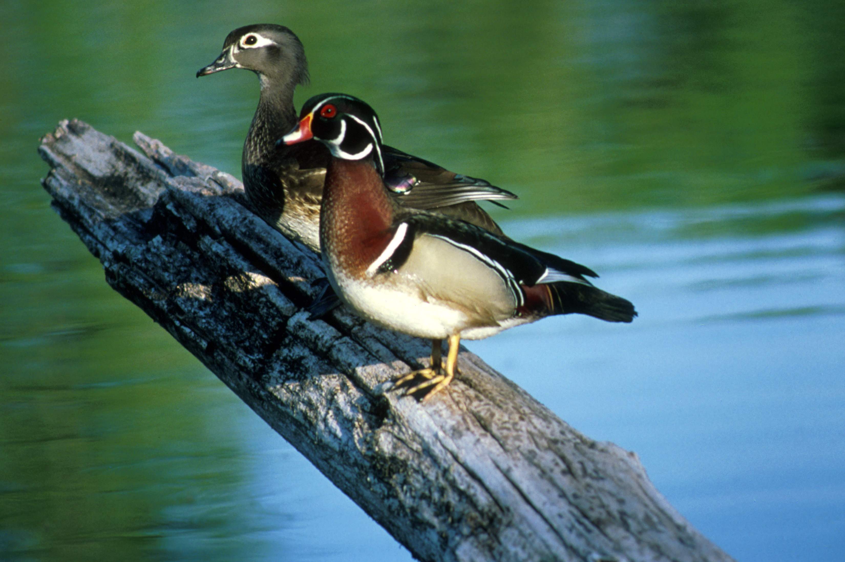

http://dsf.chesco.org

BRICE PRAIRIE CONSERVATION ASSOCIATION
2008

TABLE 3: HOODED MERGANSER PRODUCTION

 |  | Nests | % |  |  | Eggs | %
Name | Attempts | Hatched | Hatched |  | Laid | Hatched* | Hatched
Fred Craig | 2 | 0 | 0 |  | 29 | 0 | 0
Al Daus | 4 | 4 | 100 |  | 47 | 31 | 66
Greg Egan | 7 | 6 | 100 |  | 89 | 58 | 65
Jerry Guentz | 7 | 4 | 57 |  | 67 | 37 | 55
Mike Lanquist | 2 | 1 | 50 |  | 15 | 13 | 87
Amanda Marco | 7 | 5 | 71 |  | 63 | 40 | 63
Dick Marco | 8 | 8 | 100 |  | 100 | 95 | 95
Greg Marco | 1 | 1 | 100 |  | 13 | 13 | 100
Leif Marking | 22 | 21 | 95 |  | 262 | 240 | 92
Jim Nissen | 25 | 21 | 84 |  | 300 | 242 | 81
Marc Schultz/JW | 31 | 15 | 48 |  | 294 | 141 | 48
Ben Tippetts | 3 | 3 | 100 |  | 52 | 36 | 69
Leif Tolokken | 11 | 10 | 91 |  | 118 | 95 | 80
Troop 21 | 4 | 2 | 50 |  | 9 | 2 | 22
John Wetzel | 9 | 2 | 22 |  | 111 | 18 | 16
Totals | 143 | 103 | 72 |  | 1569 | 1061 | 68

*Hatched and Left Box (Ducklings Produced)

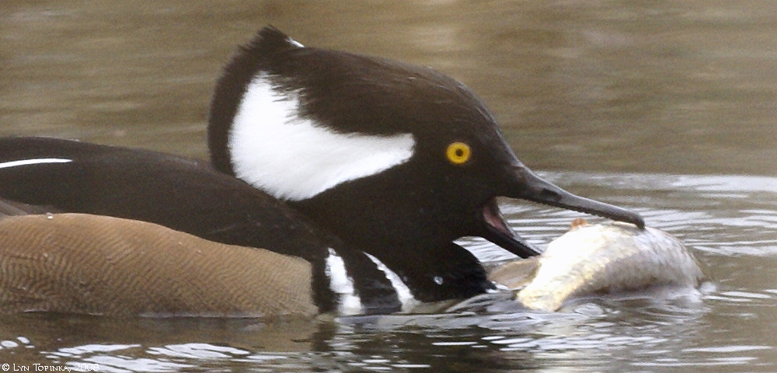
http://ridgefieldbirds.com
BRICE PRAIRIE CONSERVATION ASSICIATION
TABLE 4: DUCKLING PRODUCTION 1988 - 2008

 | Boxes |  |  | Wood Ducks |  | Mergansers |  | Total
Year | Available | Used |  | Produced |  | Produced |  | Production
1988 | 60 | 1 |  | 10 |  | - |  | 10
1989 | 100 | 5 |  | 49 |  | - |  | 49
1990 | 160 | 13 |  | 99 |  | - |  | 99
1991 | 175 | 26 |  | 169 |  | 44 |  | 213
1992 | 225 | 38 |  | 248 |  | 95 |  | 343
1993 | 275 | 51 |  | 212 |  | 158 |  | 370
1994 | 350 | 66 |  | 320 |  | 312 |  | 632
1995 | 400 | 118 |  | 552 |  | 483 |  | 1,035
1996 | 425 | 131 |  | 651 |  | 577 |  | 1,228
1997 | 500 | 137 |  | 461 |  | 672 |  | 1,133
1998 | 535 | 159 |  | 595 |  | 912 |  | 1,507
1999 | 550 | 180 |  | 644 |  | 1,093 |  | 1,737
2000 | 575 | 197 |  | 776 |  | 1,262 |  | 2,038
2001 | 580 | 182 |  | 596 |  | 1,134 |  | 1,730
2002 | 600 | 245 |  | 693 |  | 1,614 |  | 2,307
2003 | 640 | 243 |  | 704 |  | 1,489 |  | 2,193
2004 | 670 | 231 |  | 645 |  | 1,366 |  | 2,011
2005 | 675 | 241 |  | 605 |  | 1,532 |  | 2,137
2006 | 334 | 156 |  | 332 |  | 793 |  | 1,125
2007 | 394 | 153 |  | 464 |  | 1,009 |  | 1,473
2008 | 413 | 192 |  | 555 |  | 1,061 |  | 1,616
Totals |  |  |  | 9,380 |  | 15,606 |  | 24,986

