Production of Wood Duck & Hooded Merganser Eggs & Ducklings

Annual Report - 2005

Brice Prairie Conservation Association

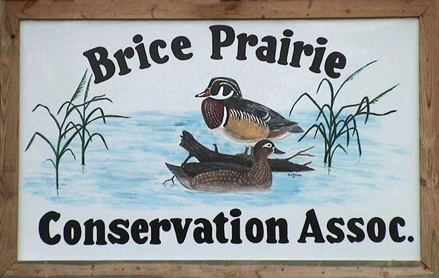

By

Leif L. Marking, Project Manager

W7917 CTH ZB
Onalaska, Wisconsin 54650
cmarking@centurytel.net
(608) 781-0323
Production of Wood Duck and Hooded Merganser Eggs and Ducklings - 2005

The Brice Prairie Conservation Association first sponsored a Wood Duck house building project in 1971 in coordination with Boy Scout Troop 21 and the Wisconsin Department of Natural Resources. Troop members and club members built 36 houses made of road sign material and placed them in the Lytles and upper Gibbs Lake areas. Most of those houses were destroyed or mutilated by woodpeckers, and the remaining wooden houses have now been removed. In 1978, the club renewed its interest in Wood Duck nesting structures and purchased 24 Tommy Tubs plastic houses. None of these houses were known to be used by Wood Ducks, probably because they were very unsteady and unstable with that type of pole mount, and the entry hole was too small for some female Wood Ducks. Interest in Wood Duck nesting structures was again renewed in 1987 when several members visited Union Slough National Wildlife Refuge, Titonka Iowa, where we were introduced to the Freon canister nesting structures by Glen L. Welp. This kind of nesting structure offered distinct advantages over the previous types. The canister Wood Duck structures are constructed from discarded 30-pound Freon canisters that normally end up in landfills. Canisters are readily available from local businesses that charge and recharge refrigeration, freezing, and air conditioning equipment. Construction of canister houses is more difficult and time consuming than construction of wooden ones. However, the canister houses are more durable than wooden structures, are rain and weatherproof, are easily removable from pipe mounts for maintenance, and can be easily opened and closed for recording information on nesting and hatching success.

In 2005, Wood Ducks established nests with more than two eggs in 60 houses. They produced 679 eggs of which 605 hatched and ducklings escaped the houses. The average number of eggs produced per nesting structure was 11.3, and the average number hatched per unit was 10.1. The Wood Ducks suffered a 10.9% loss of production due to abandonment, predation, and unhatched eggs. Hooded Mergansers established nests in 181 houses. They produced 2,395 eggs of which 1,532 hatched and ducklings escaped the houses. The average number of eggs produced per nesting structure was 13.2, and the average number hatched per unit was 8.5. The mergansers suffered a 36.0% loss of production due to abandonment, predation, and unhatched eggs. The total number of ducklings produced in monitored houses this year was 2,137. The total number in 2004 was 2,011, and in 2003 was 2,193 (Table 3).

Nest abandonment again seems to be limiting total production for the Hooded Mergansers. Forty-seven nests were abandoned and many contained large numbers of eggs. Also, predation was serious this year in Minnesota near Shore Acres. Twelve merganser nests were destroyed by raccoons; apparently one or two light-weight climbers discovered these lunch boxes on two trails. Those houses were relocated.

2

Table 1: Summary of Wood Duck Production by BPCA Members - 2005

Name | Numbers of Eggs |  | Numbers of Nests
Name | Produced | Hatched | Attempts | Abandoned | Destroyed
Bill Balmer | 28 | 28 | 3 | 0 | 0
Fred Craig | 54 | 48 | 4 | 0 | 0
Mike Fernholz | 36 | 28 | 4 | 1 | 0
Dave Fonger | 20 | 16 | 2 | 0 | 0
Jay Hesselberg/T-21 | 74 | 72 | 8 | 0 | 0
Troy Kissel | 10 | 10 | 1 | 0 | 0
Skip Klein | 22 | 22 | 2 | 0 | 0
Mike Lanquist | 34 | 31 | 3 | 0 | 0
Greg Marco | 95 | 79 | 9 | 0 | 0
Leif Marking | 146 | 142 | 10 | 0 | 0
Jim Nissen/Green Wings | 9 | 9 | 1 | 0 | 0
Bruce Van Berkum | 34 | 34 | 3 | 0 | 0
Marc Schultz/John Wetzel | 38 | 33 | 4 | 1 | 0
Leif Tolokken | 30 | 30 | 3 | 0 | 0
John Wetzel | 49 | 23 | 3 | 0 | 0
Totals | 679 | 605 | 60 | 2 | 0

3

Table 2: 2005 Summary of Hooded Merganser Production by BPCA Members

Name | Numbers of Eggs |  | Numbers of Nests
Name | Produced | Hatched | Attempts | Abandoned | Destroyed
Bill Balmer | 192 | 162 | 17 | 3 | 0
Fred Craig | 8 | 0 | 1 | 1 | 0
Dave Fonger | 21 | 20 | 2 | 0 | 0
Troy Kissel | 488 | 321 | 40 | 12 | 0
Skip Klein | 36 | 36 | 3 | 0 | 0
Jim Nissen/Green Wings | 426 | 169 | 22 | 6 | 12
Amanda Marco | 67 | 53 | 6 | 0 | 0
Dick Marco | 108 | 107 | 9 | 0 | 0
Greg Marco | 28 | 19 | 3 | 1 | 0
Leif Marking | 184 | 152 | 13 | 2 | 0
Bruce Van Berkum | 141 | 49 | 10 | 7 | 0
Marc Schultz/John Wetzel | 340 | 211 | 31 | 8 | 0
Leif Tolokken | 199 | 166 | 12 | 1 | 0
John Wetzel | 157 | 67 | 12 | 6 | 0
Totals | 2,395 | 1,532 | 181 | 47 | 12

4

Table 3: Annual Progress for Duck Nesting Success

Year | Houses Available | Houses Occupied |  | Eggs Hatched
Year | Houses Available | Attempts | Successes | Eggs Hatched
1988 | 60 | 1 | 1 | 10
1989 | 100 | 5 | 5 | 49
1990 | 160 | 13 | 11 | 99
1991 | 175 | 26 | 21 | 213
1992 | 225 | 38 | 33 | 343
1993 | 275 | 51 | 31 | 370
1994 | 350 | 66 | 62 | 632
1995 | 400 | 118 | 98 | 1,035
1996 | 425 | 131 | 117 | 1,228
1997 | 500 | 137 | 113 | 1,133
1998 | 535 | 159 | 143 | 1,507
1999 | 550 | 180 | 155 | 1,737
2000 | 575 | 197 | 176 | 2,038
2001 | 580 | 182 | 169 | 1,730
2002 | 600 | 245 | 217 | 2,307
2003 | 640 | 243 | 202 | 2,193
2004 | 670 | 231 | 186 | 2,011
2005 | 675 | 241 | 194 | 2,137
Totals |  | 2,264 | 1,934 | 20,772

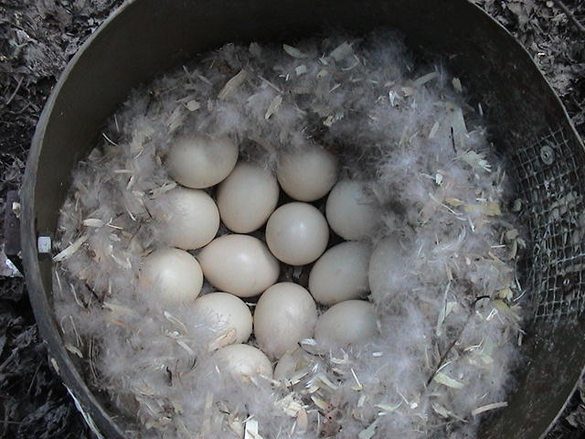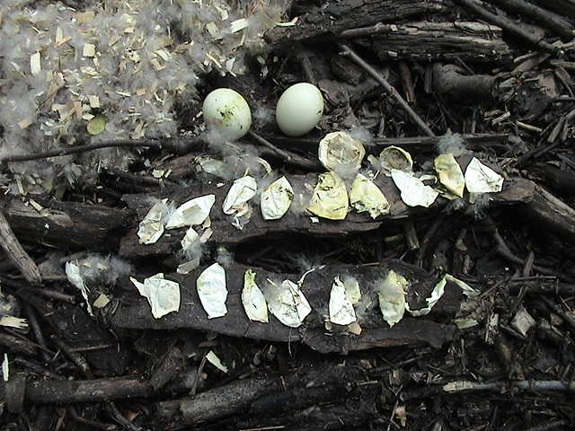

Seventeen Wood Duck eggs Fifteen membranes and two

incubating with down cover. unhatched Wood Duck eggs.

5

6

7

