Production of Wood Duck and Merganser Eggs and Ducklings

Annual Report - 2003

Brice Prairie Conservation Association

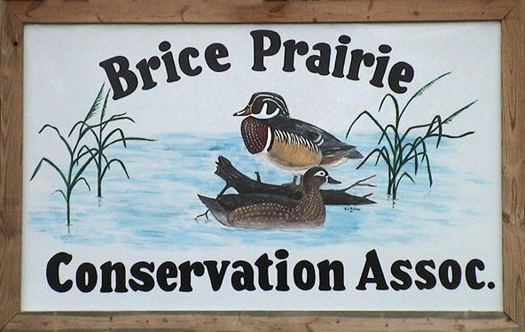

By

Leif L. Marking, Project Manager

W7917 CTH ZB
Onalaska, Wisconsin 54650
cmarking@centurytel.net
(608) 781-0323

Production of Wood Duck and Merganser Eggs and Ducklings

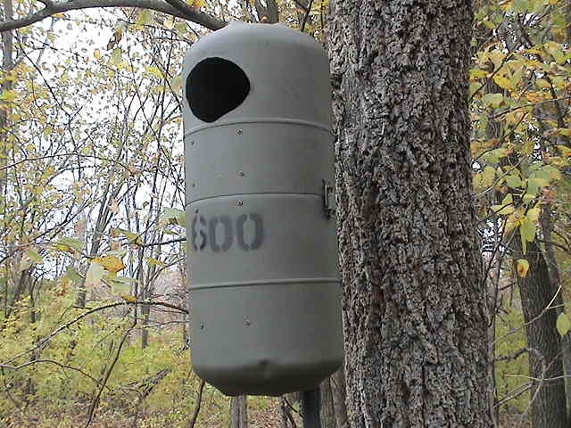 | Summary of Results for 2003

The Brice Prairie Conservation Association first sponsored a wood duck house building project in 1971 in coordination with Boy Scout Troop 21 and the Wisconsin Department of Natural Resources. Troop members and club members built 36 houses made of road sign material and placed them in the Lytles and upper Gibbs Lake areas. Most of those houses were destroyed or mutilated by woodpeckers, and the remaining wooden houses have now been removed. In 1978, the club renewed its interest in wood duck nesting structures and purchased 24 Tommy Tubs plastic houses. None of these houses were known to be used by wood ducks, probably because they were very unsteady and unstable with that type of pole mount and the entry hole was too small for some female wood ducks. Interest in wood duck nesting structures was again renewed in 1987 when several members visited Union Slough National Wildlife Refuge, Titonka Iowa, where we were introduced to the freon canister nesting structures by Glen L. Welp. This kind of nesting structure offered distinct advantages over the previous types. The canister wood duck structures are constructed from discarded 30-pound Freon canisters that normally end up in landfills. Canisters are readily available from local businesses that charge and recharge refrigeration, freezing, and air conditioning equipment. Construction of canister houses is more difficult and time consuming than construction of wooden ones. However, the canister houses are more durable than wooden structures, are rain and weatherproof, are easily removable from pipe mounts for maintenance, and can be easily opened and closed for recording information on nesting and hatching success.

In 2003, wood ducks established nests with more than two eggs in 78 houses. The produced 819 eggs of which 704 hatched and ducklings escaped the houses. The average number of eggs produced per nesting structure was 10.5 and the average number hatched per unit was 9.0. The wood ducks suffered a 14.0% loss of production due to abandonment, predation, and unhatched eggs. Hood Mergansers established nests in 165 houses. They produced 2,114 eggs of which 1,489 hatched and ducklings escaped the houses. The average number of eggs produced per nesting structure 12.8 and the average number hatched per unit was 9.0. The mergansers suffered a 34.3% loss of production due to abandonment, predation, and unhatched eggs. The total number of ducklings produced in monitored houses this year was 2,193. The total number in 2002 was 2,307, and in 2001 was 1,730 (Table 3). Nesting success and production increases have stimulated interest among club members; construction of new houses has now become a year-round activity.

Table 1: 2003 Summary of Wood Duck Production by BPCA Members

Name | Numbers of Eggs |  |  | Numbers of Nests
Name | Produced | Hatched | Infertile | Attempts | Abandoned | Destroyed
Steve Anderson | 27 | 26 |  | 2 | 0 | 0
Bill Balmer | 61 | 53 | 3 | 5 | 1 | 0
Fred Craig | 21 | 21 |  | 2 | 0 | 0
Greg Eggen/Blake Eggen | 37 | 34 |  | 3 | 0 | 0
Mike Fernholz | 50 | 41 |  | 5 | 1 | 0
Dave Fonger | 30 | 23 | 5 | 2 | 0 | 0
Fred Funk | 18 | 12 |  | 1 | 0 | 0
Jay Hesselburg/T-21 | 57 | 49 |  | 7 | 0 | 0
Troy Kissel | 12 | 10 |  | 1 | 0 | 0
Skip Klein | 50 | 50 |  | 4 | 0 | 0
Greg Marco | 123 | 93 |  | 9 | 1 | 0
Leif Marking | 140 | 128 |  | 11 | 1 | 0
Rick Osborn/Bruce Van Berkum | 80 | 62 |  | 8 | 0 | 0
Marc Schultz/John Wetzel | 63 | 54 |  | 6 | 1 | 0
Leif Tolokken | 8 | 8 |  | 8 | 0 | 0
John Wetzel | 42 | 40 | 2 | 4 | 0 | 0
Totals | 819 | 704 | 10 | 78 | 5 | 0

Table 2: 2003 Summary of Hooded Merganser Production by BPCA Members

Name | Numbers of Eggs |  |  | Numbers of Nests
Name | Produced | Hatched | Infertile | Attempts | Abandoned | Destroyed
Steve Anderson | 62 | 58 | -- | 6 | 1 | 0
Bill Balmer | 148 | 130 | 6 | 11 | 1 | 0
Fred Craig | 22 | 8 | -- | 2 | 0 | 0
Blake Eggen | 35 | 30 | -- | 4 | 0 | 0
Dave Fonger | 37 | 35 | -- | 3 | 0 | 0
Fred Funk | 47 | 15 | -- | 4 | 2 | 0
Jay Hesselburg/T-21 | 8 | 6 | -- | 1 | 0 | 0
Troy Kissel | 497 | 378 | -- | 36 | 7 | 0
Skip Klein | 14 | 14 | -- | 2 | 0 | 0
Tom Lewis/Green Wings | 215 | 123 | -- | 17 | 0 | 0
Amanda Marco | 42 | 23 | -- | 5 | 0 | 0
Dick Marco | 71 | 65 | -- | 5 | 0 | 0
Leif Marking | 429 | 330 | -- | 31 | 5 | 0
Rick Osborn/Bruce Van Berkum | 58 | 32 | -- | 4 | 2 | 0
Marc Schultz/John Wetzel | 238 | 124 | -- | 19 | 7 | 0
Ben Tippets | 68 | 50 | -- | 7 | 1 | 0
Leif Tolokken | 33 | 16 | -- | 3 | 0 | 0
John Wetzel | 90 | 52 | 6 | 7 | 2 | 0
Totals | 2,114 | 1,489 | 6 | 165 | 26 | 0

Table 3: Annual Progress for Duck Nesting Success

Year | Houses Available | Houses Occupied |  | Eggs Hatched
Year | Houses Available | Attempts | Successes | Eggs Hatched
1988 | 60 | 1 | 1 | 10
1989 | 100 | 5 | 5 | 49
1990 | 160 | 13 | 11 | 99
1991 | 175 | 26 | 21 | 213
1992 | 225 | 38 | 33 | 343
1993 | 275 | 51 | 31 | 370
1994 | 350 | 66 | 62 | 632
1995 | 400 | 118 | 98 | 1,022
1996 | 425 | 131 | 117 | 1,228
1997 | 500 | 137 | 113 | 1,133
1998 | 535 | 159 | 143 | 1,507
1999 | 550 | 180 | 155 | 1,737
2000 | 575 | 197 | 176 | 2,038
2001 | 580 | 182 | 169 | 1,730
2002 | 600 | 245 | 217 | 2,307
2003 | 640 | 243 | 202 | 2,193
Totals |  | 1,792 | 1,554 | 16,611

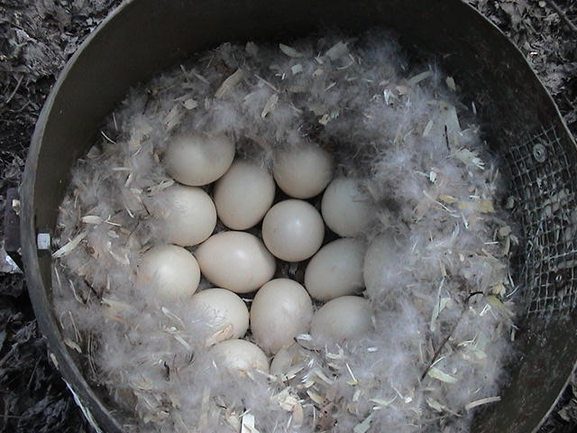 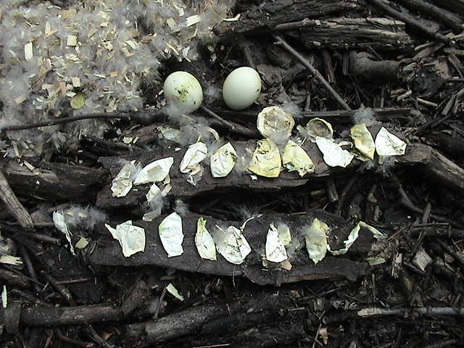\

Seventeen Wood Duck eggs Fifteen membranes and two

incubating with down cover. unhatched wood duck eggs.

