Production of Wood Duck and Merganser Eggs and Ducklings

Annual Report - 2002

Brice Prairie Conservation Association

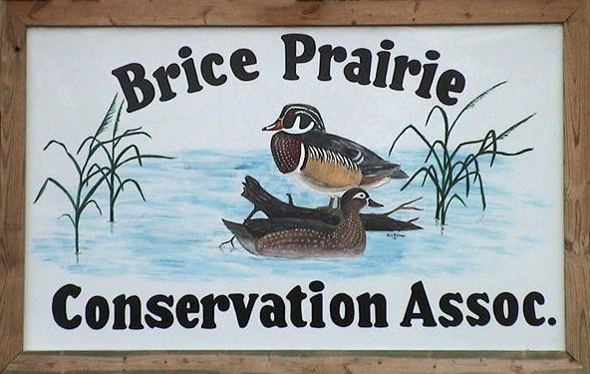

By

Leif L. Marking, Project Manager

W7917 CTH ZB
Onalaska, Wisconsin 54650
cmarking@centurytel.net
(608) 781-0323

Production of Wood Duck and Merganser Eggs and Ducklings

The Brice Prairie Conservation Association (BPCA) first sponsored a wood duck house building project in 1971 in coordination with Boy Scout Troop 21 and the Wisconsin Department of Natural Resources. Troop members built 36 houses made of road sign material and placed them in the Lytles and upper Gibbs Lake areas. Most of those houses were destroyed or mutilated by woodpeckers, and the remaining wooden houses have now been removed. In 1978, the club renewed its interest in wood duck nesting structures and purchased 24 Tommy Tubs plastic houses. None of these houses were known to be used by wood ducks, probably because they were very unsteady and unstable with that type of pole mount, and the entry hole was too small for some female wood ducks.

Interest in wood duck nesting structures was again renewed in 1987 when several BPCA members visited Union Slough National Wildlife Refuge, Titonka, Iowa, where we were introduced to the freon canister nest structures by Glen L. Welp. This type of nesting structure offered distinct advantages over the previous types. The canister wood duck structures are constructed from discarded 30-pound freon canisters that normally end up in landfills. Canisters are readily available from local businesses that charge and recharge refrigeration, freezing, and air conditioning equipment. Construction of canister houses is more difficult and time-consuming than construction of wooden ones. However, the canister houses are more durable than wooden structures, are rain and weatherproof, are easily removable from pipe mounts for maintenance, and can be easily opened and closed for recording information on nesting and hatching success.

In 2002, wood ducks established nests with more than two eggs in 71 houses (Table 1). They produced 817 eggs of which 693 hatched and the ducklings escaped the houses. The average number of eggs produced per unit was 11.5, and the average hatched per successful unit was 10.7. The wood ducks suffered a 15.2% loss of production due to abandonment, predation, and unhatched eggs.

Hooded mergansers established nests in 173 houses (Table 2). They produced 2,063 eggs of which 1,614 hatched and the ducklings escaped the houses. The average number of eggs produced per nesting structure was 11.9, and the average number hatched per unit was 10.9. The mergansers suffered a 21.8% loss of production due to abandonment, predation, and unhatched eggs.

The total number of ducklings produced in monitored houses this year was 2,307 (Table 3). The total number in 2001 was 1,730 and in 2000 was 2,038. Nesting attempts increased this year along with successful nestings and production. The primary reason for the 2001 slump was perhaps the high level of flood water on the Mississippi River during the prime nesting season. Some active nests on pool 8 that year were flooded and destroyed and nesting ducks were discouraged from starting nests when houses were only a few feet or inches above the water level. A similar situation occurred in 1993 and correspondingly nesting success decreased from the previous year.

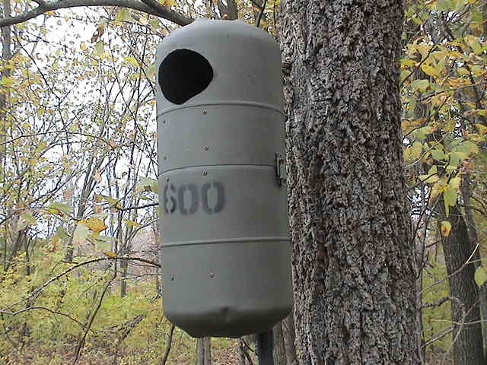

Canister type house mounted to tree.

Hooded merganser nesting numbers seem to be increasing faster than those for wood ducks. Although wood duck numbers were sustained this year, some people monitoring houses suspect that mergansers may be better competitors for these artificial structures. Certainly the early nesting mergansers claim boxes that could be used by wood ducks. Most of our trails contain excess houses to minimize the dominating factor of mergansers. Some duck nests have eggs of both species, suggesting that nest site competition and nest parasitism was evident.

Only two nestings were destroyed by racoon on one trail this year. Apparently, a light-weight racoon discovered how to climb the steel tree mounting pipe and snatch the eggs out through the entry hole. Such is the perils of mother nature.

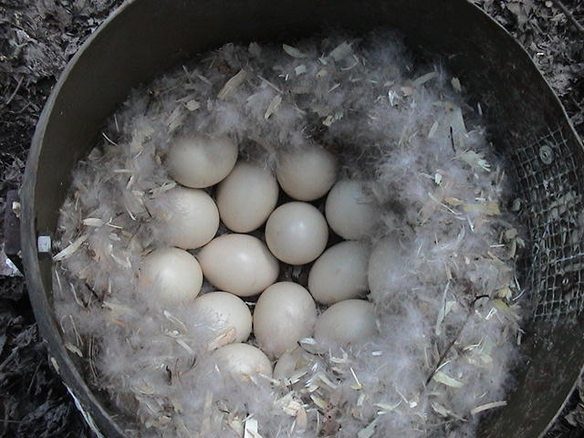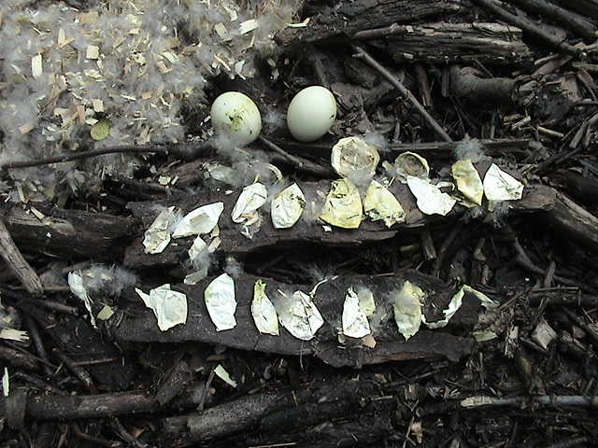

Seventeen Wood Duck eggs Fifteen membranes and two

incubating with down cover. unhatched wood duck eggs.

Table 1: Summary of Wood Duck Production by BPCA Members

Name | Numbers of Eggs |  |  | Numbers of Nests
Name | Produced | Hatched | Infertile | Attempts | Abandoned | Destroyed
Steve Anderson | 13 | 13 | -- | 2 | 0 | 0
Bill Balmer | 46 | 33 | -- | 4 | 1 | 0
Fred Craig | 34 | 31 | -- | 2 | 0 | 0
Greg Eggen | 49 | 48 | -- | 5 | 0 | 0
Mike Fernholz | 53 | 46 | -- | 6 | 1 | 0
Dave Fonger | 30 | 25 | -- | 2 | 0 | 0
Jay Hesselburg/T-21 | 76 | 67 | -- | 9 | 0 | 0
Troy Kissel | 38 | 27 | -- | 3 | 1 | 0
Skip Klein | 52 | 51 | -- | 4 | 0 | 0
Tom Lewis/Green Wings | 6 | 6 | -- | 1 | 0 | 0
Greg Marco | 11 | 11 | -- | 1 | 0 | 0
Leif Marking | 247 | 189 | 9 | 18 | 1 | 2
Rick Osborn/Bruce Van Berkum | 62 | 56 | -- | 6 | 0 | 0
Marc Schultz/John Wetzel | 72 | 63 | -- | 6 | 0 | 0
Funk/Tippets | 18 | 17 | -- | 1 | 0 | 0
Ben Tippets | 10 | 10 | -- | 1 | 0 | 0
Totals | 817 | 693 | -- | 71 | 4 | 2

Table 2: Summary of Hooded Merganser Production by BPCA Members

Name | Numbers of Eggs |  |  | Numbers of Nests
Name | Produced | Hatched | Infertile | Attempts | Abandoned | Destroyed
Steve Anderson | 31 | 28 | -- | 3 | 0 | 0
Bill Balmer | 103 | 79 | -- | 7 | 1 | 0
Fred Craig | 34 | 31 | -- | 3 | 0 | 0
Greg Eggen | 28 | 12 | -- | 2 | 1 | 0
Dave Fonger | 33 | 30 | -- | 3 | 0 | 0
Fred Funk/Tippets | 48 | 38 | -- | 4 | 1 | 0
Jay Hesselburg/T-21 | 9 | 3 | -- | 1 | 0 | 0
Troy Kissel | 646 | 460 | -- | 54 | 14 | 0
Skip Klein | 13 | 13 | -- | 1 | 0 | 0
Tom Lewis/Green Wings | 133 | 133 | -- | 12 | 0 | 0
Amanda / Dick Marco | 65 | 62 | -- | 7 | 1 | 0
Leif Marking | 350 | 327 | 11 | 28 | 1 | 0
Rick Osborn/Bruce Van Berkum | 46 | 44 | -- | 2 | 0 | 0
Marc Schultz/John Wetzel | 315 | 229 | -- | 32 | 2 | 1
Ben Tippets | 60 | 54 | -- | 5 | 0 | 0
Leif Tolokken | 15 | 15 | -- | 1 | 0 | 0
John Wetzel | 134 | 56 | -- | 8 | 3 | 0
Totals | 2,063 | 1,614 | 11 | 173 | 24 | 1

Table 3: Annual Progress for Duck Nesting Success

Year | Houses Available | Houses Occupied |  | Eggs Hatched
Year | Houses Available | Attempts | Successes | Eggs Hatched
1988 | 60 | 1 | 1 | 10
1989 | 100 | 5 | 5 | 49
1990 | 160 | 13 | 11 | 99
1991 | 175 | 26 | 21 | 213
1992 | 225 | 38 | 33 | 343
1993 | 275 | 51 | 31 | 370
1994 | 350 | 66 | 62 | 632
1995 | 400 | 118 | 98 | 1,022
1996 | 425 | 131 | 117 | 1,228
1997 | 500 | 137 | 113 | 1,133
1998 | 535 | 159 | 143 | 1,507
1999 | 550 | 180 | 155 | 1,737
2000 | 575 | 197 | 176 | 2,038
2001 | 580 | 182 | 169 | 1,730
2002 | 600 | 245 | 217 | 2,307
Totals |  | 1,549 | 1,352 | 14,418

