Purple Loosestrife Biological Control Project: 2003 Annual Report

(B. Blossey, Cornell University)

Prepared by:

Brice Prairie Conservation Association (BPCA)

Brad Foss, Project Manager
W7583 Saint Croix Avenue
Holmen, WI 54636
fosser@charter.net

October 2003
Introduction

Two thousand three marked the third consecutive year of the Brice Prairie Conservation Association’s (BPCA’s) involvement in the biological control of purple loosestrife (Lythrum salicaria) on pool 7 of the Mississippi River. Working in conjunction with the United States Fish and Wildlife Service (USFWS) and the Wisconsin Department of Natural Resources (WDNR), the BPCA released approximately 3,000 to 4,000 Galerucella beetles at a heavily infested purple loosestrife stand near Onalaska, Wisconsin. This report is intended to give the reader a summary of 2003’s activities along with a status report of the BPCA’s 2001 and 2002 release sites.

2003 Release Site

Planning for the 2003 release initially began during the summer of 2002 when a decision was made to find a beetle release site that would be more readily accessible to the general public than the 2001 and 2002 release sites were. After conferring with the USFWS, a site was chosen on USFWS property near Onalaska, Wisconsin. The site, located on pool 7 of the Mississippi River, is situated just off of La Crosse County Highway Z and adjacent to the State Bike Trail, making it easily accessible by vehicle, bicycle, or walking (Figures 1 and 2).

Once the 2003 site was selected, focus shifted towards how to set up the beetle rearing insectary. In past years, loosestrife plants were collected just after the spring thaw and transported to the insectary for potting. Although this approach was successful in both 2001 and 2002, collection, transportation, and transplantation of the plants proved to be an arduous task. So, as is human nature, an easier approach to establishing an insectary was looked at.

It was decided on by BPCA membership to try and overwinter 2002’s insectary plants. Since the insectary plant root crowns were still intact and viable (loosestrife plants in the insectary had regrown to approximately 3 feet tall after the 2002 release and by the end of the growing season), the wading pools were filled with water and the plants left outside to overwinter. No extra care was given to the plants during the winter months.

In April of 2003, the insectary was officially set up. Leftover woody debris was removed from the plants, the wading pools were topped off with water, and fertilizer was added to each pot. After approximately one and a half months and still no sign of plant growth in the insectary, it became apparent that the plants had not overwintered successfully and that new plants would have to be collected.

On May 24, 10 new plants ranging in size from 2 to 18 inches were collected for the insectary. Approximately 2 weeks later, with the insectary plants still showing signs of stress from transplantation, 115 Galerucella beetles were added to the insectary (Figure 3). On June 14, only one week after the beetles had been introduced to the insectary, the insectary plants were nearly100 percent defoliated and the beetles were subsequently taken to the release site.

At the release site, it was apparent that some reproduction had taken place among the insectary beetles, as there were both adult and egg life stages present. A conservative estimate of 1,000 to 2,000 adult beetles and eggs were subsequently released.

Two thousand additional adult beetles were purchased and released on July 12, raising the aggregate total of beetles and eggs released at the 2003 site to approximately 3,000 to 4,000 individuals. Five monitoring quadrants were later staked out that August.

2002 Release Site

Spring monitoring of the 2002 release site took place on May 29 (Figures 1 and 4). Damage to purple loosestrife foliage at the site ranged from 1 to 5 percent in all five of the monitoring quadrants surveyed. Adult beetles and eggs were only seen in one of the five monitoring quadrants; however, numerous adult beetles were seen outside of the monitoring quadrants. Indications were that the beetles had overwintered successfully and were actively feeding and reproducing at the site.

2001 Release Site

Spring monitoring of the 2001 release site also took place on May 29 (Figures 1 and 5). Damage to purple loosestrife foliage at the site ranged from 1 to 25 percent, depending on which monitoring quadrant was being surveyed. Damage to the loosestrife foliage during last year’s survey ranged from 1 to 50 percent. No adult beetles were found in the monitoring quadrants during this year’s survey; however, numerous beetles were seen outside of the monitoring quadrants. In comparison, one to nine adult beetles were found in each of the five monitoring quadrants during last year’s survey. As with the 2002 release site, indications were that the beetles had overwintered successfully and were actively feeding and reproducing at the site. Two thousand and three marked the second successful reproductive year for the beetles at this site.

Conclusions

Despite the setbacks encountered during 2003, the Purple Loosestrife Biological Control Project is still showing a positive progression. Although no decline in loosestrife density can yet be seen at the release sites, beetle damage, reproduction, and the presence of adult beetles are being observed on an annual basis.

One factor that may prove to have a negative impact on the Project is the fluctuating water level of the Mississippi River. Rising pool elevations during critical times of the beetle’s lifecycle, e.g. spring emergence, may produce a higher level of beetle mortality than one would normally see in loosestrife stands associated with a lentic environment such as a lake or pond. This increased mortality could prove to be a limiting factor for the Project’s success; however, only three years into the Project, it is purely conjecture at this point.

Future plans are to continue as in the past, i.e., raising insectary beetles and purchasing adult beetles for immediate release at 2004’s release site, which will be located just adjacent to 2003’s release site.
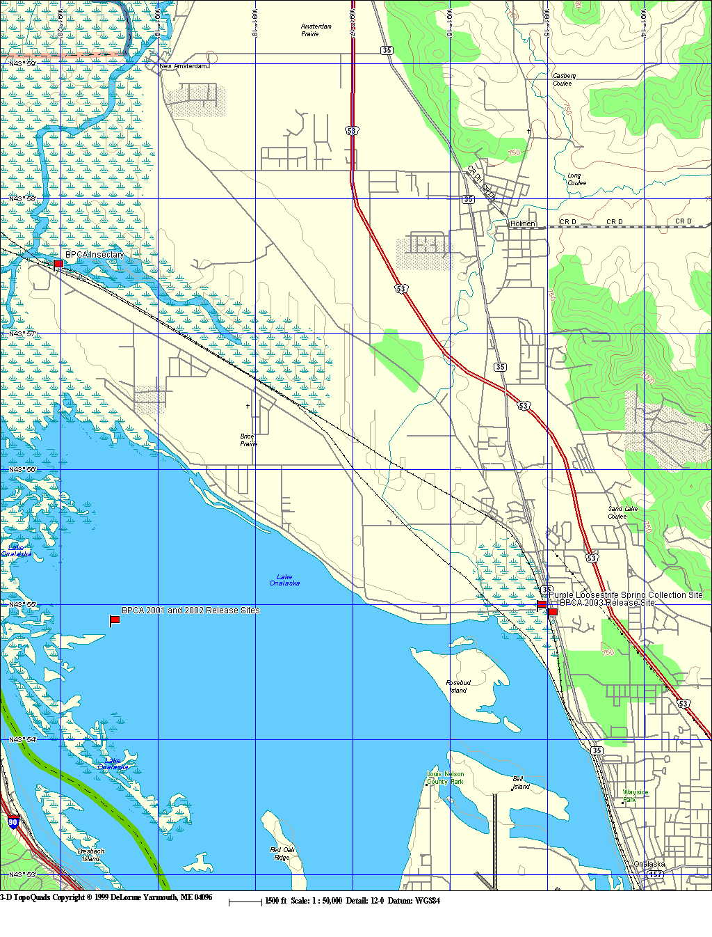
Figure 1.-General location map showing the Brice Prairie Conservation Association’s 2001 - 2003 Galerucella beetle release sites, beetle rearing insectary, and spring purple loosestrife collection site, Mississippi River, pool 7.
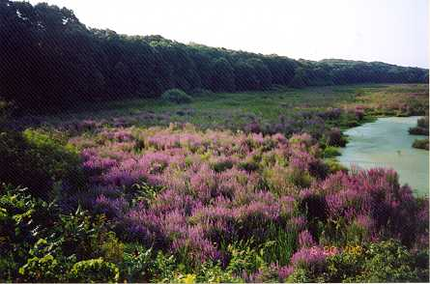
Figure 2.-Photograph of the Brice Prairie Conservation Association’s 2003 Galerucella beetle release site, taken from La Crosse County Highway Z, Mississippi River, pool 7.

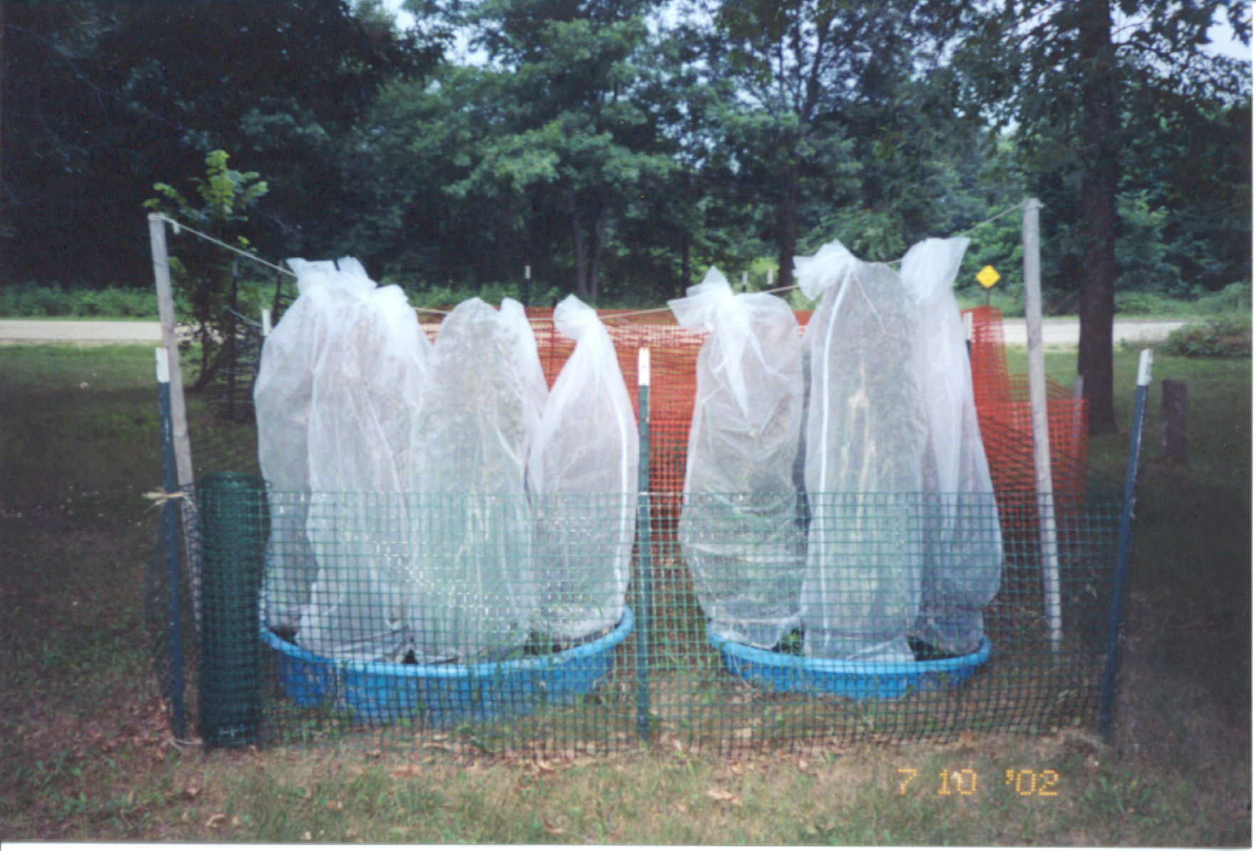
Figure 3.-Photograph of the Brice Prairie Conservation Association’s Galerucella beetle rearing insectary, Onalaska, Wisconsin.
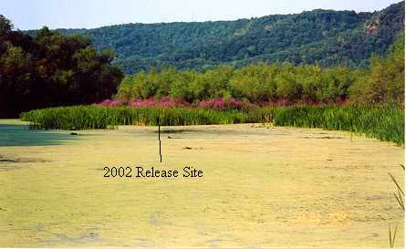
Figure 4.-Photograph of the Brice Prairie Conservation Association’s 2002 Galerucella beetle release site, Mississippi River, pool 7.

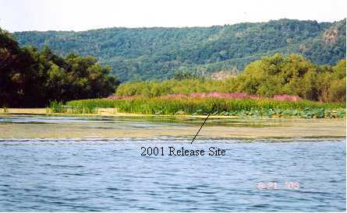
Figure 5.-Photograph of the Brice Prairie Conservation Association’s 2001 Galerucella beetle release site, Mississippi River, pool 7.

