Purple Loosestrife Biological Control Project: 2002 Annual Report

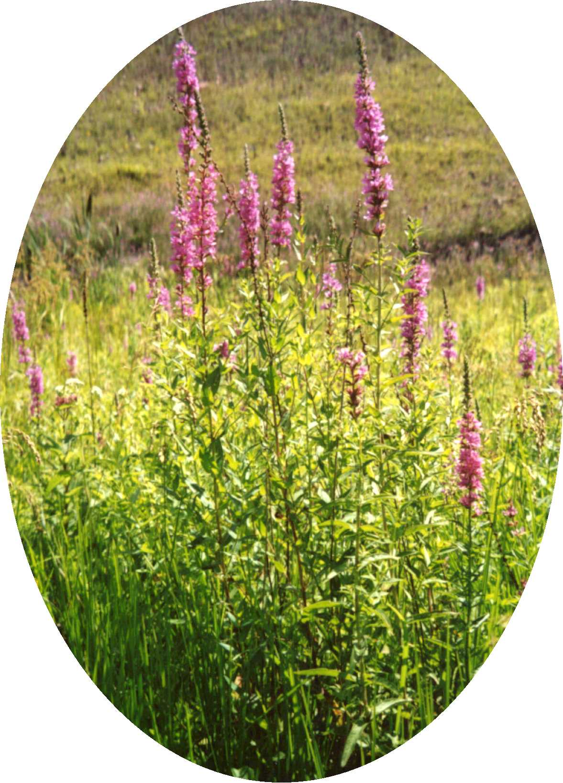

Prepared By:

Brice Prairie Conservation Association

Brad Foss, Project Manager
W7583 Saint Croix Avenue
Holmen, WI 54636

August 2002

Introduction

Purple loosestrife (Lythrum salicaria) is a beautiful, but aggressive and invasive wetland plant that arrived in North America in the early 1800’s. Plants were first brought to the United States (US) by early settlers for their flower gardens, and the seeds were present in the ballast tanks of European ships that used soil to weigh down the vessels for stability on the ocean. Since it was first introduced, purple loosestrife has spread westward and can be found across much of Canada and the US.

Purple loosestrife is a very hardy perennial that can rapidly degrade wetlands, diminishing their value for wildlife habitat. When purple loosestrife gets a foothold, the habitat where fish and wildlife feed, seek cover, reproduce, and rear young quickly becomes choked under a sea of purple flowers. Areas where wild rice grows and is harvested, and where fish spawn, are degraded. An estimated 190,000 hectares of wetlands, marshes, pastures, and riparian meadows are affected in North America each year, with an economic impact estimated in the millions of dollars.

For years, people have tried without success to eradicate purple loosestrife and it has now become clear that total eradication is impossible. Current efforts focus on two approaches to controlling, but not eradicating purple loosestrife: 1) keeping it out of wetlands where it is not currently established and 2) where it is present, managing its density so that native plants and animals can prosper.

The most effective control methods are based on the scale of the infestation. In habitats where just a few plants exist or the infestation is localized in a very small area (less than 1 acre), it is best to dig them up. In addition, where permitted, plants may be treated with an approved herbicide. RODEO is an effective herbicide registered for use in wetland habitats, however, it is non-selective and will kill most vegetation it contacts.

Where hundreds of mature plants exist, or the infestation is spread over several acres, digging and the use of herbicides may be impractical. In this case, biological control (the use of plant specific predators, such as insects) is likely to be the only practical long-term management option.

Biological Control

Biological control is when humans use a pest’s natural enemies to reduce its density and the damage that it causes. These natural enemies may be predators, parasites, or pathogens. In the case of purple loosestrife, the predator turns out to be tiny insects used either separately or in conjunction with one another to attack the loosestrife plant.

The first of these insects are the Galerucella or leaf beetles. The Galerucella beetles feed on purple loosestrife bud, leaf, and stem tissue causing defoliation and prevention of flowering/seed production (Figure 1). Continued defoliation leads to plant death.

The other predator used to combat purple loosestrife is the Hylobius weevil. Hylobius is a weevil whose larvae mine into root tissue weakening and ultimately killing the plant.

Once introduced into a purple loosestrife stand, large impacts of the beetles are generally realized in 5 to 15 years. However, larger releases and better rearing techniques may help shorten the impact time to as little as three years.

Because they survive exclusively on purple loosestrife, the number of the beetles in any area is expected to rise and fall based on the amount of loosestrife present. As the plant becomes less common, the beetles will have a harder time finding food, they will produce fewer offspring, and consequently, their population will decline. Once established, the beetles will continue to control loosestrife on a permanent basis.

Project Background

During 2001, the Brice Prairie Conservation Association (BPCA), a small conservation association centered near Onalaska, Wisconsin decided to pursue the idea of using biological control to combat the growing purple loosestrife infestation on pool 7 of the Mississippi River. Working with representatives from the United States Fish and Wildlife Service (USFWS) and the Wisconsin Department of Natural Resources (WDNR), the BPCA made the decision to purchase 100 Galerucella beetles from the WDNR for rearing in an insectary and subsequent release, and also purchase an additional 2000 adult Galerucella beetles that would be released in conjunction with the insectary beetles. This same protocol would be followed during 2002.

2001 Review

As with any project of its type, the first step was locating a release site. The site had to have an adequate density of purple loosestrife to support the beetles and also be located in an area that was only periodically flooded, since the beetles are terrestrial and overwinter in the upper layer of the topsoil. A release site was chosen in the Sommer’s Chute area of pool 7 of the Mississippi River (Figures 2 and 5).

The next step was to collect approximately 6 to 10 purple loosestrife plants for the beetle rearing insectary. Insectary plants were collected from a loosestrife stand located near County Highway Z in La Crosse County during early May and then transported to the BPCA clubhouse where the insectary was located (Figure 6).

During June, approximately 110 adult Galerucella beetles arrived from the WDNR. These beetles were evenly distributed among the eight adult loosestrife plants in the insectary (Figure 3). Once introduced to the insectary, the adults reproduced, laid eggs, and died. After two to three weeks, the eggs began hatching and larvae were evident. At this point, the larvae began voraciously feeding on the insectary plants before pupating into the adult stage.

By mid-July, the adults in the insectary began congregating at the top of the netting that was placed over the insectary plants to confine the beetles. On July 14, with the insectary plants destroyed, the beetles were taken to the release site in Sommer’s Chute and released (Figures 2 and 5). A conservative estimate of 5000 Galerucella beetles were reared and released from the original 110. On July 18, the additional 2000 adult beetles that had been ordered arrived via Fed Ex and were quickly transported to the release site and released.

In addition to releasing the approximately 7000 Galerucella beetles, five monitoring quadrants were also set up at the release site. Each quadrant, measuring 1 meter by 1 meter is used to conduct quantitative annual monitoring of the release site.

2002 Review

Planning for 2002’s activities began in late 2001 when the decision was made to replicate the previous year’s activities and choose a release site adjacent to the 2001 site, so as to concentrate the general area with beetles and improve/expedite the chance for success (Figures 4 and 5). Insectary plants were again collected from an area along County Highway Z in La Crosse County and the insectary was set up at the BPCA Clubhouse (Figure 6). Ten plants were collected as opposed to eight in 2001. Plants were also collected approximately one month earlier, in April, rather than in May.

Spring monitoring of the 2001 release site took place on May 24. Damage to the loosestrife plants at the site ranged from 5 to 50 percent, depending on which of the five quadrants was being surveyed. In addition to the one to nine adult beetles being observed in each quadrant, two eggs were also seen. Indications were that the majority of the beetles had overwintered successfully and were actively feeding and reproducing at the site.

Insectary starter beetles arrived in early June and approximately ten Galerucella were placed in each of the ten insectary plants (Figure 3). By the end of June, eggs had been laid and no adults could be seen on the plants.

Release of the insectary raised adult beetles took place on July 12, with approximately 8000 beetles being released (Figures 4 and 5). The next day, on July 13, the additional 2000 pre-ordered adult beetles arrived and were released at the site.

Conclusions

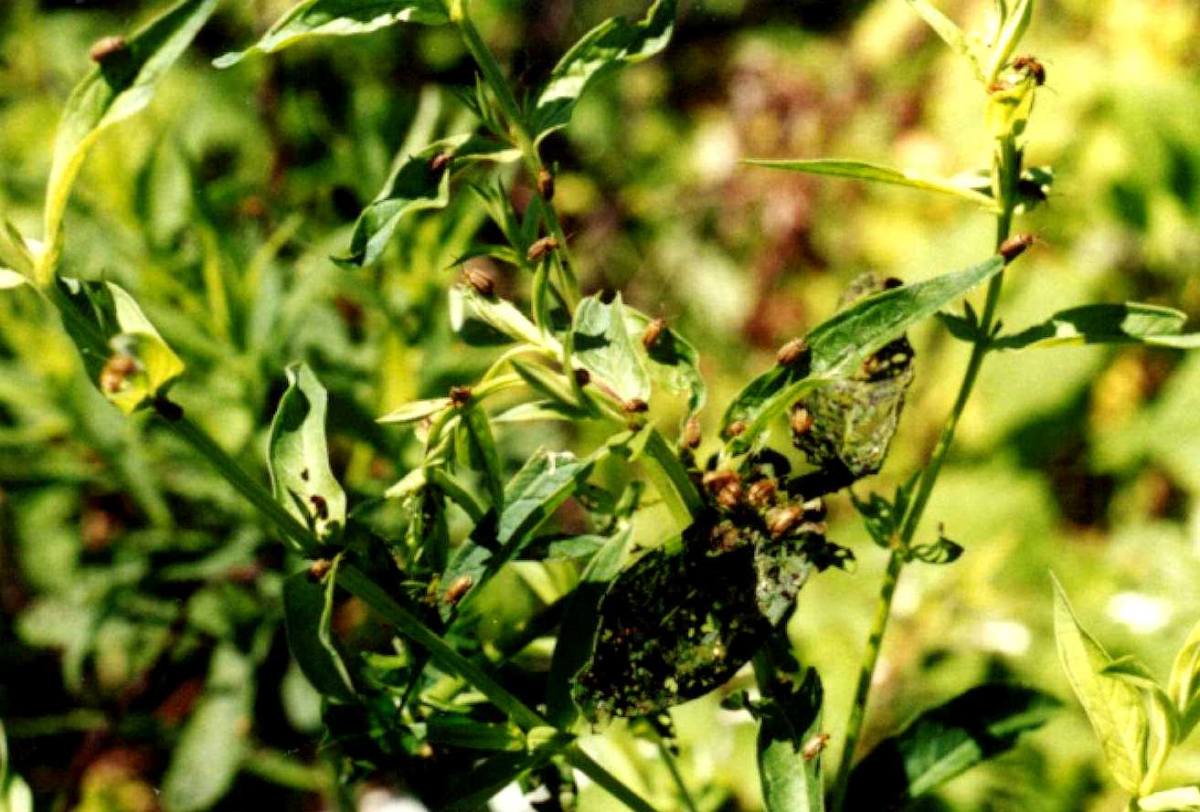
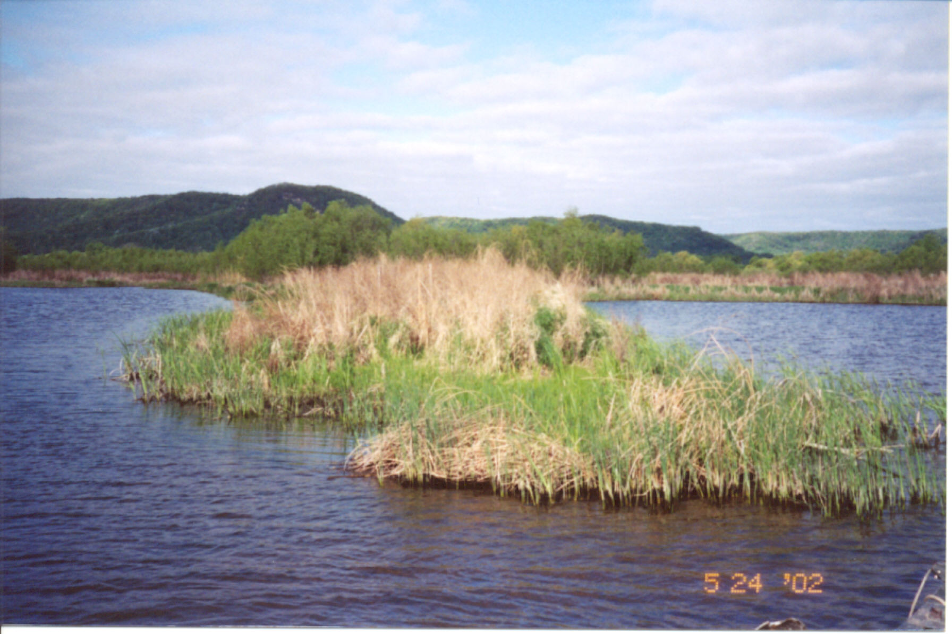
Two years into the Purple Loosestrife Biological Control Project, it appears that things are going as planned. Although it’s too early into the Project to note a decline in loosestrife density at the release sites, beetle damage, reproduction, and the presence of adult beetles are all being observed at the two release sites and may be an indicator of good things to come. Future plans are to continue as in the past, i.e., raising insectary beetles and purchasing adult beetles for immediate release, with the only change being the selection of a more high profile or more public accessible site.
Figure 1. -Galerucella beetles feeding on purple loosestrife plants.

Figure 2. -Brice Prairie Conservation Association 2001 Galerucella beetle release site, Mississippi River, pool 7.

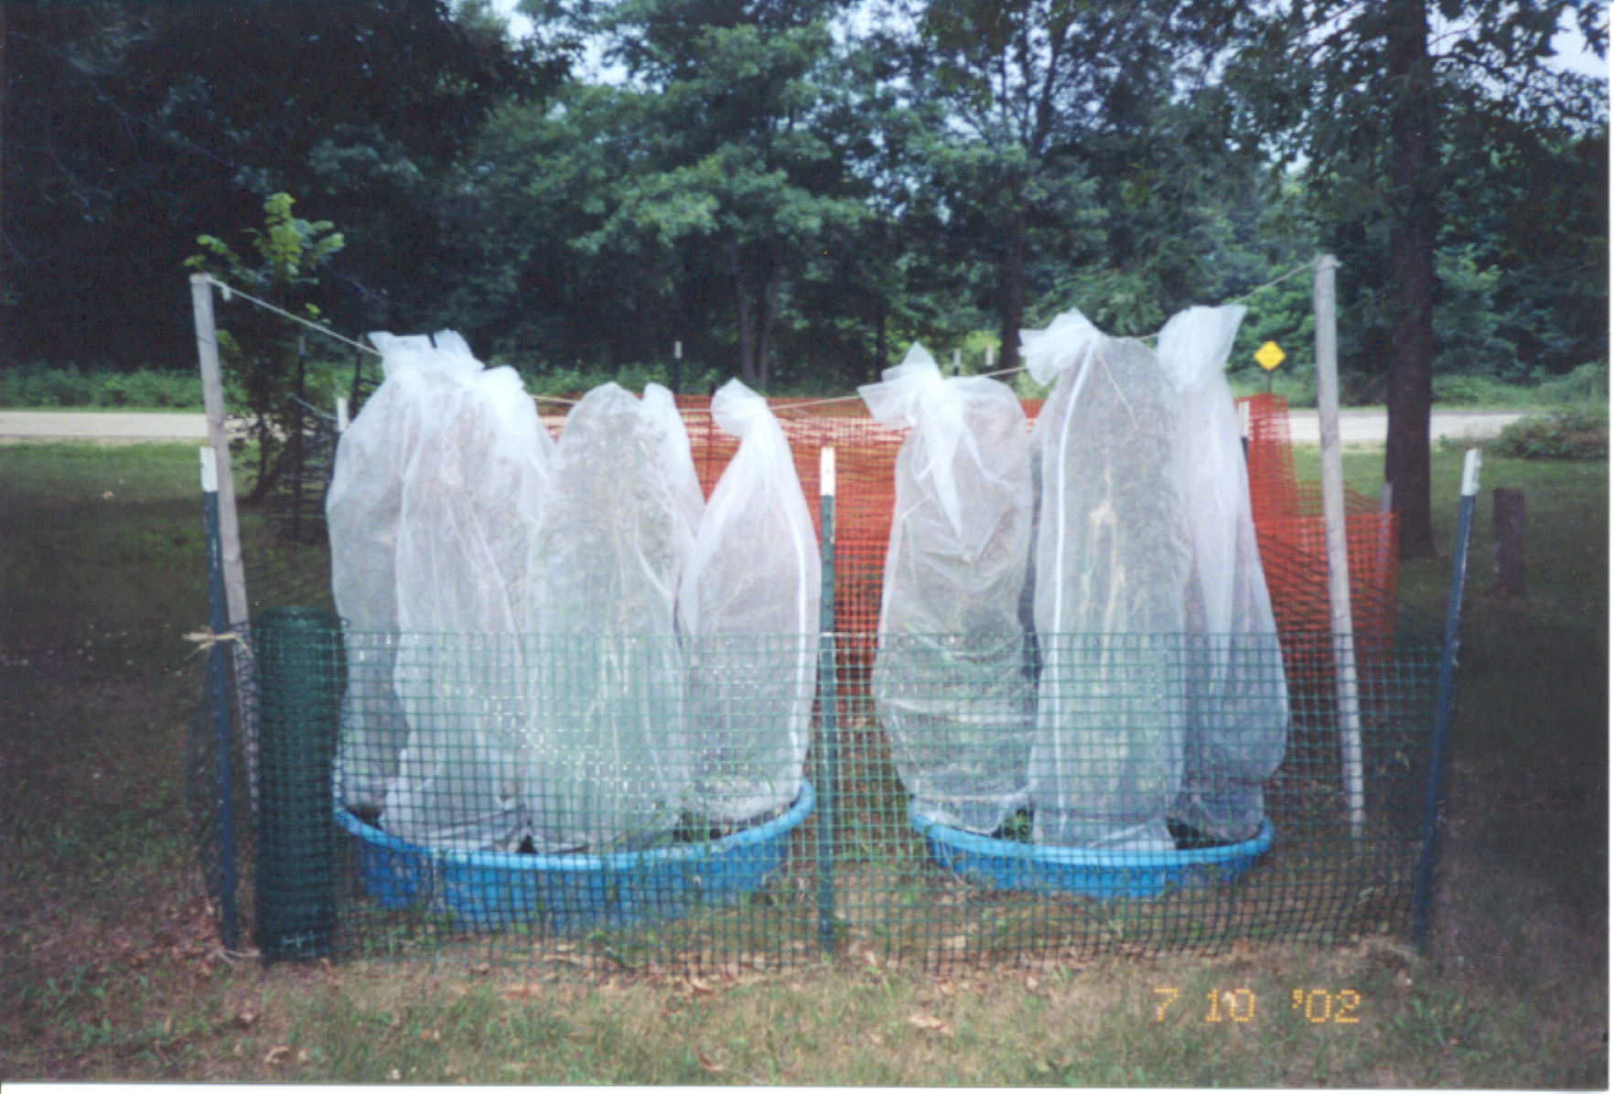
Figure 3. -Brice Prairie Conservation Association Galerucella beetle rearing insectary, Brice Prairie, Wisconsin.

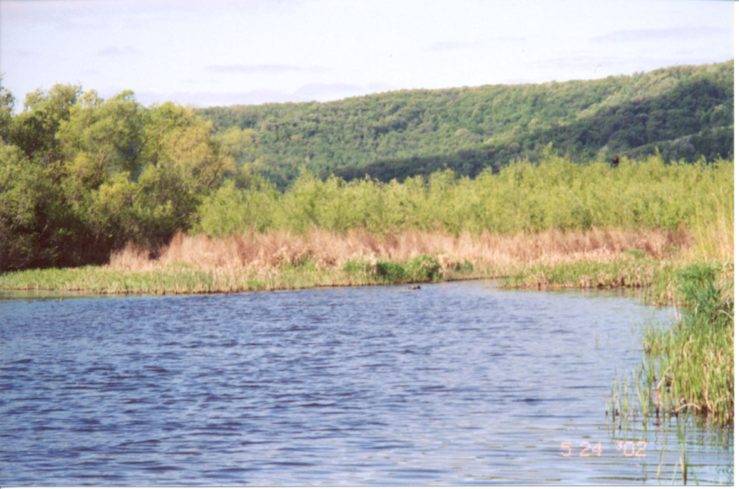
Figure 4. -Brice Prairie Conservation Association 2002 Galerucella beetle release site, Mississippi River, pool 7.

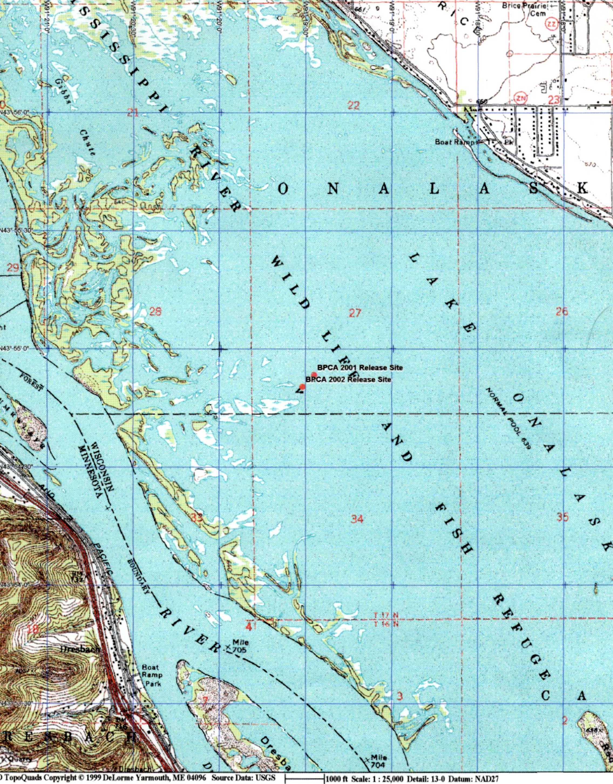
Figure 5. -Location map showing the Brice Prairie Conservation Association’s 2001 and 2002 Galerucella beetle release sites, Mississippi River, pool 7.

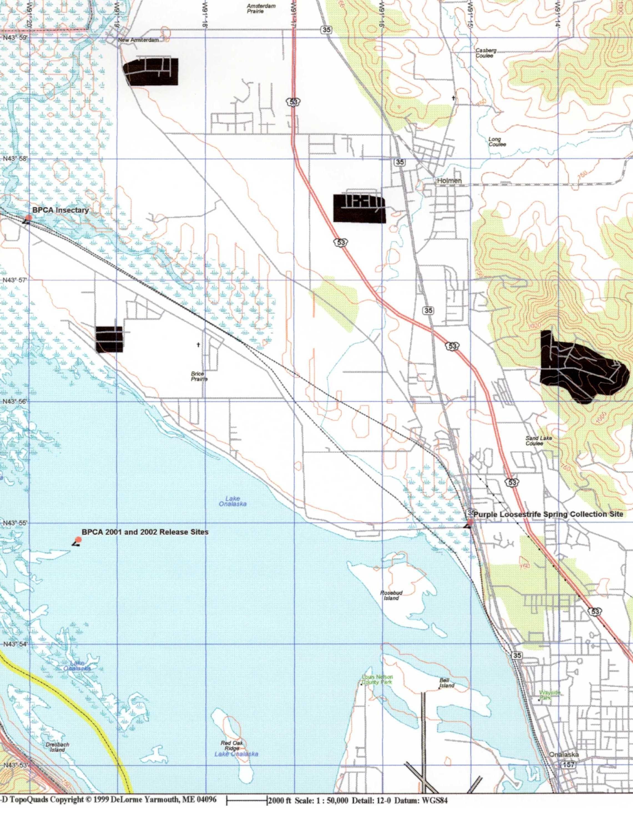
Figure 6. -Location map showing the Brice Prairie Conservation Association’s 2001 and 2002 Galerucella beetle release sites, beetle insectary, and spring purple loosestrife collection site, Mississippi River, pool 7.

