Purple Loosestrife Biological Control Project: 2004 Annual Report

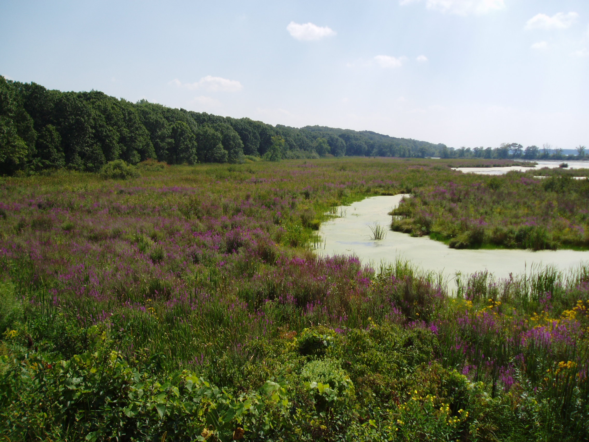

Prepared by:

Brice Prairie Conservation Association (BPCA)
http://www.briceprairieconservation.org

Brad Foss, Project Manager
W7583 Saint Croix Avenue
Holmen, WI 54636
Email: fosser@charter.net

December 2004
Introduction

Two thousand four marked the fourth consecutive year of the Brice Prairie Conservation Association’s (BPCA’s) involvement in the biological control of purple loosestrife (Lythrum salicaria) on Pool 7 of the Mississippi River. Working in conjunction with the United States Fish and Wildlife Service (USFWS) and the Wisconsin Department of Natural Resources (WDNR), the BPCA reared and released approximately 12,000 Galerucella spp. beetles at a heavily infested purple loosestrife stand near Onalaska, Wisconsin. This report is intended to give the reader a summary of 2004’s activities along with a progress report on the Association’s previous release efforts.

2004 Beetle Rearing and Release Summary

As in past years, preparation for the rearing and release of Galerucella spp. beetles began a year in advance with the decision to conduct a second release at the BPCA’s 2003 release site (Figure 1). The decision to release beetles at the same location two years in a row was twofold. First, due the problems encountered rearing beetles in 2003 and the subsequent low number of beetles released that year (see Purple Loosestrife Biological Control Project: 2003 Annual Report), additional beetles would need to be released at the site to create a viable and self-sustaining beetle population. Secondly, the location of the site, situated just off La Crosse County Highway Z and adjacent to the State Bike Trail, makes it easily accessible by vehicle, bicycle, or foot. Thus, it is an excellent location for interested parties to not only observe the effects of Galerucella spp. beetles on purple loosestrife, but also to observe the negative impacts that purple loosestrife can have on wetland ecosystems.

In order to ensure better beetle rearing success than what was experienced in 2003, ten purple loosestrife root crowns were collected for the insectary with the ground still partially frozen on March 20. This was approximately three weeks earlier than any previous collection. Within one month, loosestrife shoots approximately two-inches in height, were observed in six of the ten insectary pots. By late May, plant height ranged from 12 to 30-inches in all ten pots.

On May 28, 100 Galerucella spp. beetles (10 per pot) were added to the insectary (Figure 2). Within days of their introduction to the insectary, damage was noted on all insectary plants. One month later, on June 29, the mostly defoliated insectary plants and approximately 10,000 beetles were transported to the release site. One day later an additional 2,000 Galerucella spp. beetles were also released at the site raising the aggregate total of adult beetles released at the 2003/2004 release site to approximately 12,000 individuals.

2004 Spring Monitoring Results

2003 Release Site

Spring monitoring of the 2003 release site took place on May 27. Adult beetles were observed in one of the five monitoring quadrats; however, a number of other adult beetles were also observed scattered throughout the release site. Some plant damage was evident, but at much lower levels than were seen during spring surveys conducted at the 2001 and 2002 release sites. Considering the low number of beetles released at the site in 2003, results of the spring survey were encouraging.

2002 Release Site

Spring monitoring of the 2002 release site took place on May 27. Damage to purple loosestrife foliage at the site was noted in all five monitoring quadrats as well as to a number of plants located outside of the monitoring quadrats (Figure 3). No adult beetles were observed in the five monitoring quadrats; however, adult beetles were seen outside of the monitoring quadrats. This site is slightly more aquatic than the 2001 release site as a number of the loosestrife plants were partially submerged. This may be a factor as to why fewer adult beetles were seen at this site versus the 2001 release site. A number of the loosestrife plants at this release site also had been browsed on, possibly by whitetail deer.

2001 Release Site

Spring monitoring of the 2001 release site also took place on May 27. Damage was noted on approximately 90 to 100 percent of the plants at the site. Adult beetles were observed in three of the five monitoring quadrats and on numerous loosestrife plants outside of the quadrats. A large beetle egg mass was also observed in one of the quadrats. Overall, loosestrife plant size and density were noticeably less than what was seen in non-release areas.

Conclusions

Despite the setbacks encountered during 2003, the Purple Loosestrife Biological Control Project is still showing a positive progression. A slight decline in loosestrife plant size and density was noted during the spring survey at the 2001 release site and beetle damage, reproduction, and the presence of adult beetles were observed at all three release sites.

Of most significance was the discovery that beetles had migrated from the 2001 and 2002 release sites across open water channels to loosestrife stands where no previous beetles had been released. While the beetles dispersing from the release sites and finding additional food sources may slow results at the individual release sites, it will still have an overall negative impact on the loosestrife population of the area.

Plans for 2005 are to intensify the rearing of beetles by setting up two insectaries compared to one as in past years. This will substantially increase the number of beetles being released and should help to expedite the destruction of loosestrife in the area. Beetles raised during 2005 will be released at the 2003/2004 release site near Onalaska, Wisconsin (Figure 1).

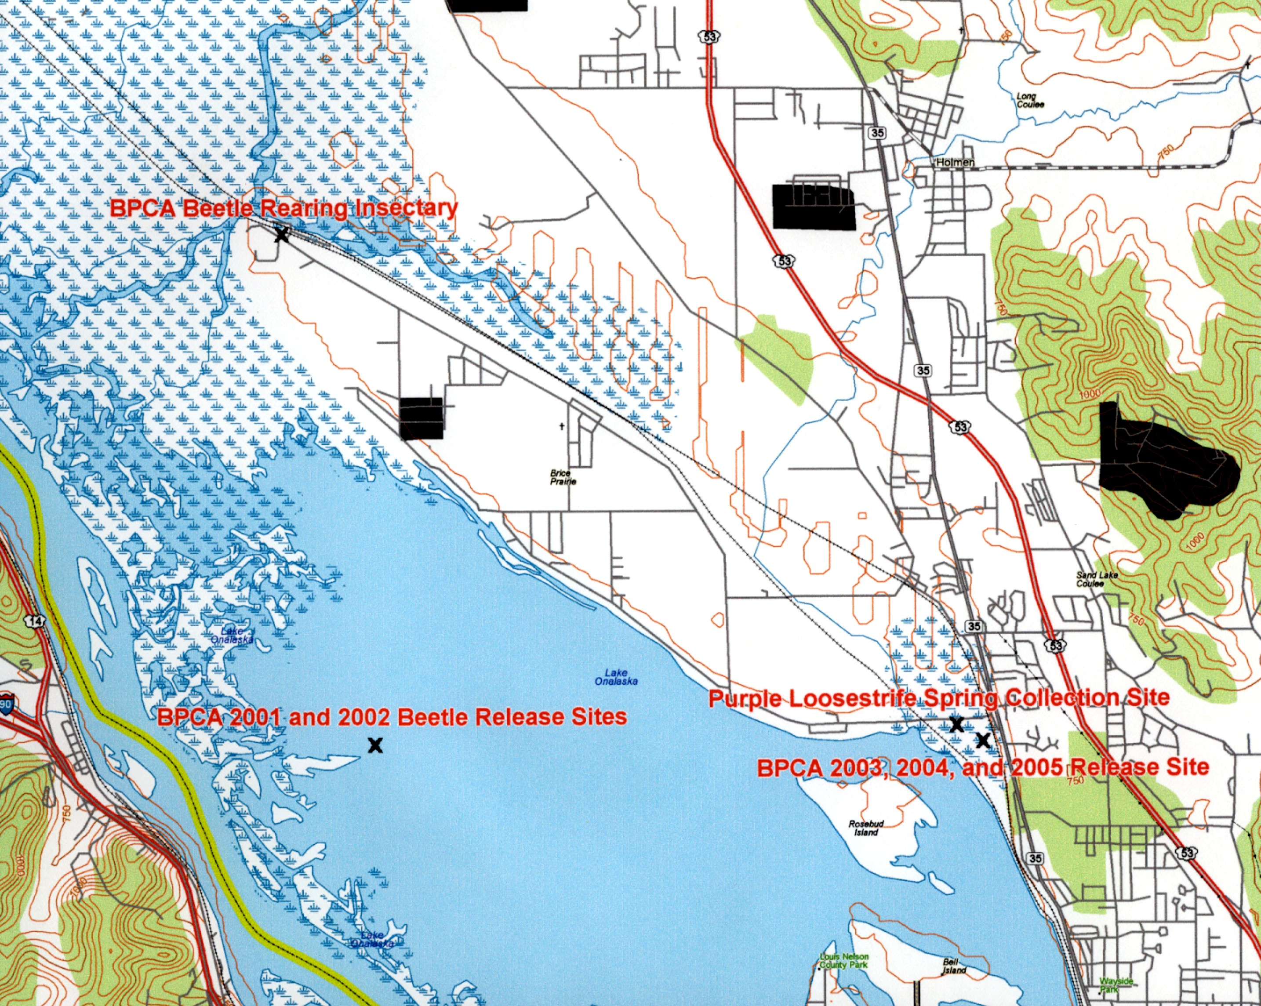

Figure 1.-Location map showing the Brice Prairie Conservation Association’s 2001 - 2005 Galerucella spp. beetle release sites, beetle rearing insectary, and spring purple loosestrife collection site, Mississippi River, pool 7, Onalaska, Wisconsin.
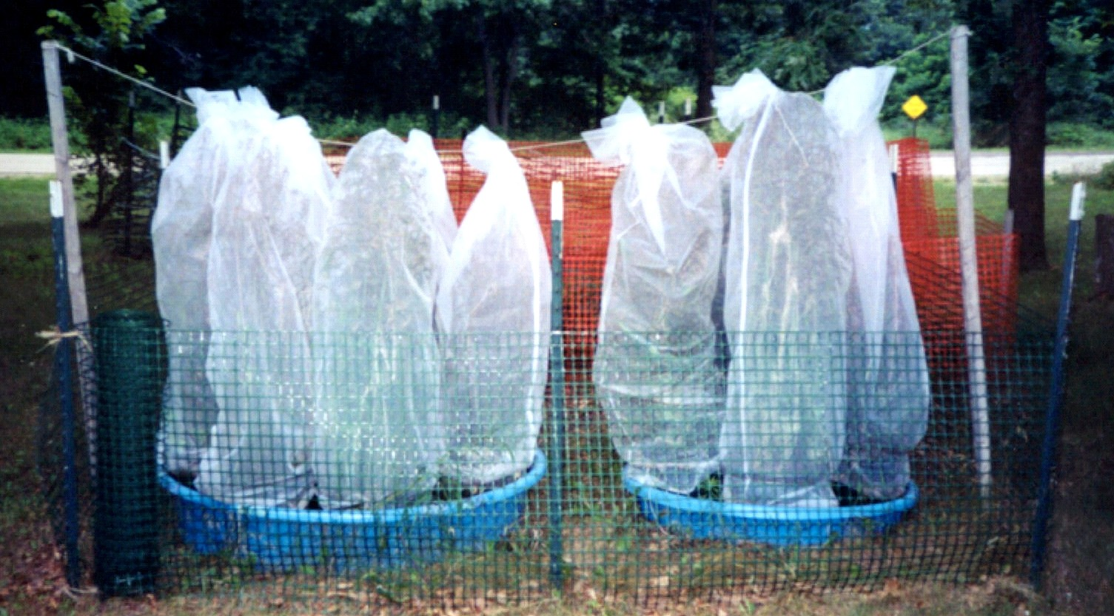

Figure 2.-Photograph of the Brice Prairie Conservation Association’s Galerucella spp. beetle rearing insectary, Onalaska, Wisconsin.

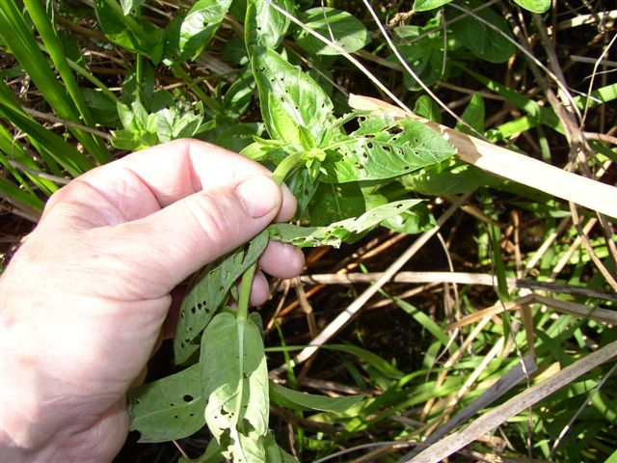

Figure 3.-Purple loosestrife foliage damage resulting from Galerucella spp. beetle feeding activity.

