Production of Eastern Bluebirds in Monitored Houses

Annual Report - 2016

Brice Prairie Conservation Association

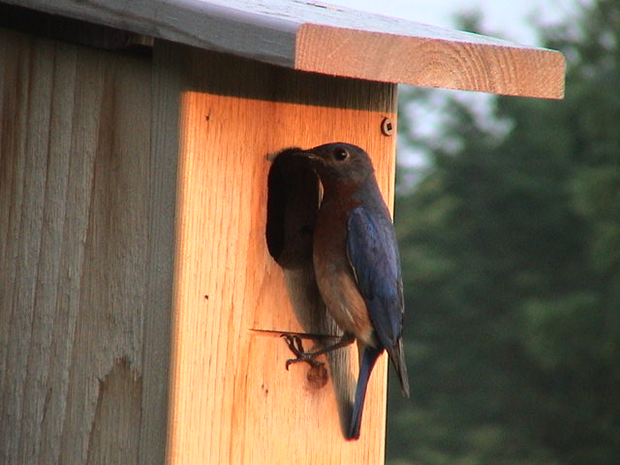

By

Leif L. Marking, Project Manager

351 Mason St NW Ap 220
Onalaska, Wisconsin 54650
lcmarking@gmail.com
608- 779-1794

Production of Eastern Bluebirds in Monitored Houses

Introduction: Bluebirds are cavity-nesting songbirds that are unable to create their own nesting cavities. Natural cavity availability declined significantly when non-native House Sparrows and European Starlings were introduced to this country over 150 years ago. They are victorious competitors for nest cavities and vicious predators of bluebird eggs and young. However, bluebird populations have been increasing since the birth of the North American Bluebird Society (NABS) in 1978 followed by many state chapters such as the Bluebird Restoration Association of Wisconsin (BRAW). Our Brice Prairie Conservation Association (BPCA) members have recorded our bluebird production activities since 1992 and annually reported the numbers to the above organizations. Technical information and instructions for producing bluebirds are available from websites of NABS (www.nabluebirdsociety.org), BRAW (www.BRAW.org), and BPCA (www.briceprairieconservation.org). The purpose of this report is to summarize the numbers of bluebirds produced by club members this year, recognize increases or decreases over previous years, identify problems that influenced production, and evaluate procedures to increase future production.

Procedures: We have selected the NABS-style house to promote bluebird production because the design is practical, they are easy to construct, maintain, and clean, and bluebirds readily occupy them. These cedar houses are mounted on 7-foot steel T-type fence posts that are covered with a 5 ft. section of 1-1/2” PVC pipe treated with car wax for mammalian predator control. The houses are usually placed 200 yards or more apart to respect the territorial nature of bluebirds and to encourage maximum production of bluebirds. New houses are built with convertible air vents, so the vents can be closed on site to reduce mortality of eggs and young during sustained cold spells in early nesting and to avoid black fly mortality. Site and habitat selection favors bluebird ecology with large, open, grazed or mowed areas where bluebirds can forage for ground insects. House Sparrow competition was diminished appreciably by avoiding active farm and livestock feeding operations. Houses were placed at least 200 feet from woods and thickets to minimize House Wren competition. Weekly observations were recorded in notebooks of choice, and those results were transferred to spreadsheets for calculations, evaluations, and presentations. These spreadsheets accumulate numbers of eggs, numbers hatched, and count of bluebirds and other cavity- nesting songbirds fledged. Finally, the numbers are consolidated for each member’s totals as well as individual and total production rates for all club members and bluebird associates.

2

Results and Discussion: We monitored 608 bluebird boxes this year, 49 fewer than last year. Those boxes produced 2,560 bluebird fledglings, a decrease of 378 compared to the previous year. Our bluebird production rate also decreased this year (4.21 fledglings per box), primarily due to the late spring season that delayed nesting activity and discouraged third nesting later in the year. Cold temperatures in early spring interfered with first nesting that resulted in poor hatch rates and nestling mortality. This delay offered competitive House Sparrows, Tree Swallows, and wrens opportunities to dominate boxes normally used by bluebirds. Some nestling mortality was due to Black Fly gnat infestations. A dilute solution of Permethrin spray was used with good success to combat the black flies.

We also produced a total of 386 Tree Swallows, 58 Black Capped Chickadees and 122 House Wrens. These cavity nesting species readily occupy the bluebird boxes, especially if they are located on the edge of bluebird habitat. House Sparrow attacks were more numerous for many trails and restricted bluebird production. The bluebirds prefer diversified agriculture, mowed, or grazed areas, and if the boxes are properly located and spaced the bluebirds will occupy them before the swallows (serious competitors) are capable of nesting in early spring.

In addition, my 12 bluebird associates produced 458 bluebird fledglings, 69 Tree Swallows, and 42 House Wrens as identified in the second table. These folks are not members of BPCA, but they like bluebirds and our technology for producing them, so they are willing to monitor and contribute to our efforts. They realize their efforts also benefit the bluebird population so we are thankful. This associate concept encourages more people to get involved in serious monitoring and keeping good records. Associates also reported more competition and predation with House Wrens and House Sparrows this year.

We attribute our success for producing bluebirds to providing a box with a cavity size and shape that appeals to them, selection of ideal habitat for box location, spacing the boxes at least 200 yards, providing predator prevention for every box, moving boxes that fail to attract bluebirds after one year, and monitoring weekly to ensure the cavities are available to bluebirds that are searching for a home. House Sparrows interfered with bluebird nesting in many locations. In fact, 34 of my 95 houses were invaded, some multiple times. Van Ert sparrow traps were used to eliminate 75 House Sparrows on my trail. House Wrens again were important predators and competitors on many bluebird trails. Our technology for bluebird production is effective, and we feel satisfied and rewarded with the bluebird responses to our efforts with 55,752 fledges reported since 1992.

3

Consolidated Nest Box Summary 2016
Brice Prairie Conservation Association – Individuals
Monitor's Name | Nest Boxes | Bluebirds Fledged | Bluebird Production Rate | Other Species Fledged |  |  | Total Other Species | Total Birds Fledged | Overall Production Rate
 |  |  |  | TS | CH | HW | Total Other Species | Total Birds Fledged | Overall Production Rate
John Adank | 8 | 30 | 3.75 |  |  |  | 0 | 30 | 3.75
Iler Anderson | 107 | 331 | 3.09 | 153 | 26 | 5 | 184 | 515 | 4.81
Steven Anderson | 23 | 117 | 5.09 | 18 | 5 | 11 | 34 | 151 | 6.57
Bill Balmer | 9 | 51 | 5.67 |  | 7 |  | 7 | 58 | 6.44
Fred Craig | 78 | 507 | 6.50 | 30 |  | 34 | 64 | 571 | 7.32
Dan & Gail Filzen | 9 | 34 | 3.78 |  |  | 17 | 17 | 51 | 5.67
Dave Fonger | 65 | 312 | 4.80 | 23 | 16 | 6 | 45 | 357 | 5.49
Brad Foss | 5 | 8 | 1.60 |  |  |  | 0 | 8 | 1.60
Leif Marking | 95 | 442 | 4.65 | 17 |  | 3 | 20 | 462 | 4.86
Peter Tabor | 1 | 4 | 4.00 |  |  |  | 0 | 4 | 4.00
Leif Tolokken | 48 | 236 | 4.92 | 71 | 4 | 4 | 79 | 315 | 6.56
Joni Welda | 8 | 30 | 3.75 | 5 |  |  | 5 | 35 | 4.38
Associates | 152 | 458 | 3.01 | 69 |  | 42 | 111 | 569 | 3.74
 | 608 | 2,560 | 4.21 | 386 | 58 | 122 | 566 | 3,126 | 5.14

Species Key: TS - Tree Swallow, CH - Chickadee, HW – Wren

4

Consolidated Nest Box Summary 2016
Leif Marking Bluebird Associates

Associate's Name | Nest Boxes | Bluebirds Fledged | Bluebird Production Rate | Other Species Fledged |  |  | Total Other Species | Total Birds Fledged | Overall Production Rate
 |  |  |  | TS | CH | HW | Total Other Species | Total Birds Fledged | Overall Production Rate
Jan and Jim Brady | 6 | 38 | 6.33 | 11 |  |  | 11 | 49 | 8.17
Louis Benchina | 24 | 62 | 2.58 | 7 |  | 8 | 15 | 77 | 3.21
Harry & Ellen Caulum | 25 | 62 | 2.58 |  |  | 24 | 24 | 86 | 3.44
Verdel Dawson | 14 | 71 | 5.07 |  |  |  | 0 | 71 | 5.07
Ron Parker | 13 | 30 | 2.31 | 17 |  |  | 17 | 47 | 3.62
Morgan Jostad | 5 | 8 | 1.60 |  |  |  | 0 | 8 | 1.60
Tim Knudson | 10 | 30 | 3.00 | 29 |  |  | 29 | 59 | 5.90
Stephanie Lubinsky | 15 | 63 | 4.20 |  |  |  | 0 | 63 | 4.20
John & Louise Leary | 9 | 39 | 4.33 | 5 |  |  | 5 | 44 | 4.89
Mary Dresser | 9 | 18 | 2.00 |  |  |  | 0 | 18 | 2.00
Jean Ruhser | 9 | 7 | 0.78 |  |  |  | 0 | 7 | 0.78
Fred Schaldach | 13 | 30 | 2.31 |  |  | 10 | 10 | 40 | 3.08
 | 152 | 458 | 3.01 | 69 | 0 | 42 | 111 | 569 | 3.74

Species Key: TS - Tree Swallow, CH - Chickadee, HW – House Wren

5

Bluebird Production in Houses of Different Types
Year | Number |  | Production  Rate | Predominant  House Type
Year | Houses | Fledged | Production  Rate | Predominant  House Type
1992 | 29 | 62 | 2.1 | Hill Lake
1995 | 42 | 80 | 1.9 | Hill Lake
1996 | 54 | 109 | 2.0 | Tree Branch
1997 | 65 | 145 | 2.2 | Tree Branch
1998 | 78 | 212 | 2.7 | Tree Branch
1999 | 91 | 265 | 2.9 | Herman Olson
2000 | 101 | 324 | 3.2 | Herman Olson
2001 | 142 | 544 | 3.8 | NABS
2002 | 285 | 1,138 | 4.0 | NABS
2003 | 506 | 2,001 | 4.0 | NABS
2004 | 741 | 3,066 | 4.1 | NABS
2005 | 880 | 4,233 | 4.8 | NABS
2006 | 858 | 4,756 | 5.5 | NABS
2007 | 916 | 5,399 | 5.9 | NABS
2008 | 977 | 4,228 | 4.3 | NABS
2009 | 1,019 | 5,252 | 5.2 | NABS
2010 | 1,001 | 4,915 | 4.9 | NABS
2011 | 936 | 3,294 | 3.5 | NABS
2012 | 862 | 4,679 | 5.4 | NABS
2013 | 796 | 2,884 | 3.6 | NABS
2014 | 724 | 2,668 | 3.7 | NABS
2015 | 657 | 2,938 | 4.5 | NABS
2016 | 608 | 2,560 | 4.2 | NABS
 | Total | 55,752

By Members of Brice Prairie Conservation Association

6

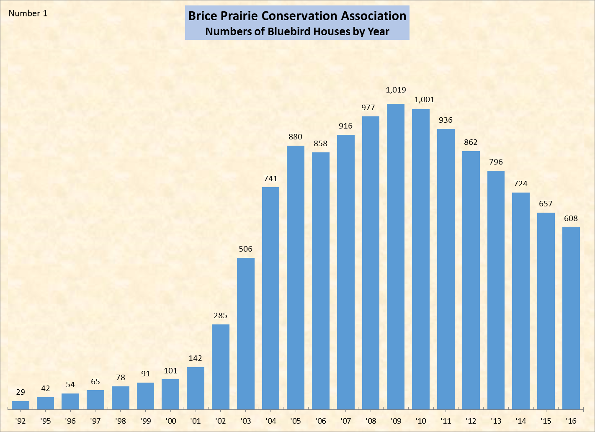

7

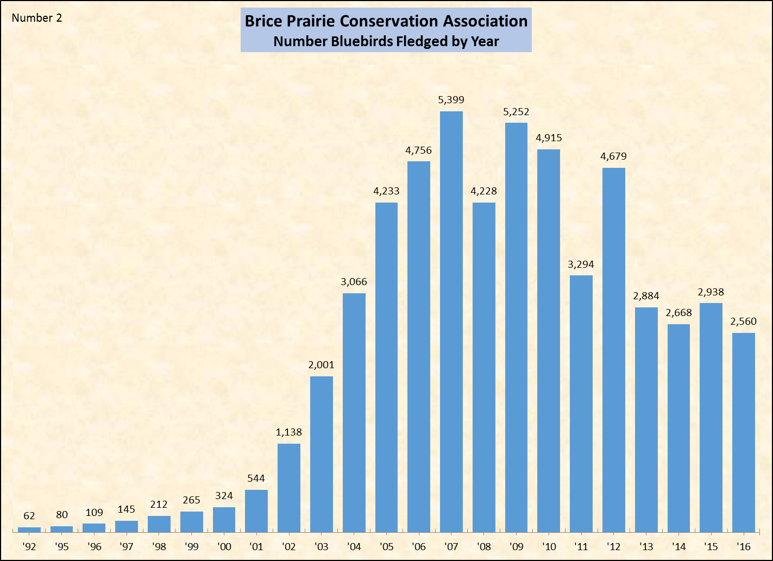

8

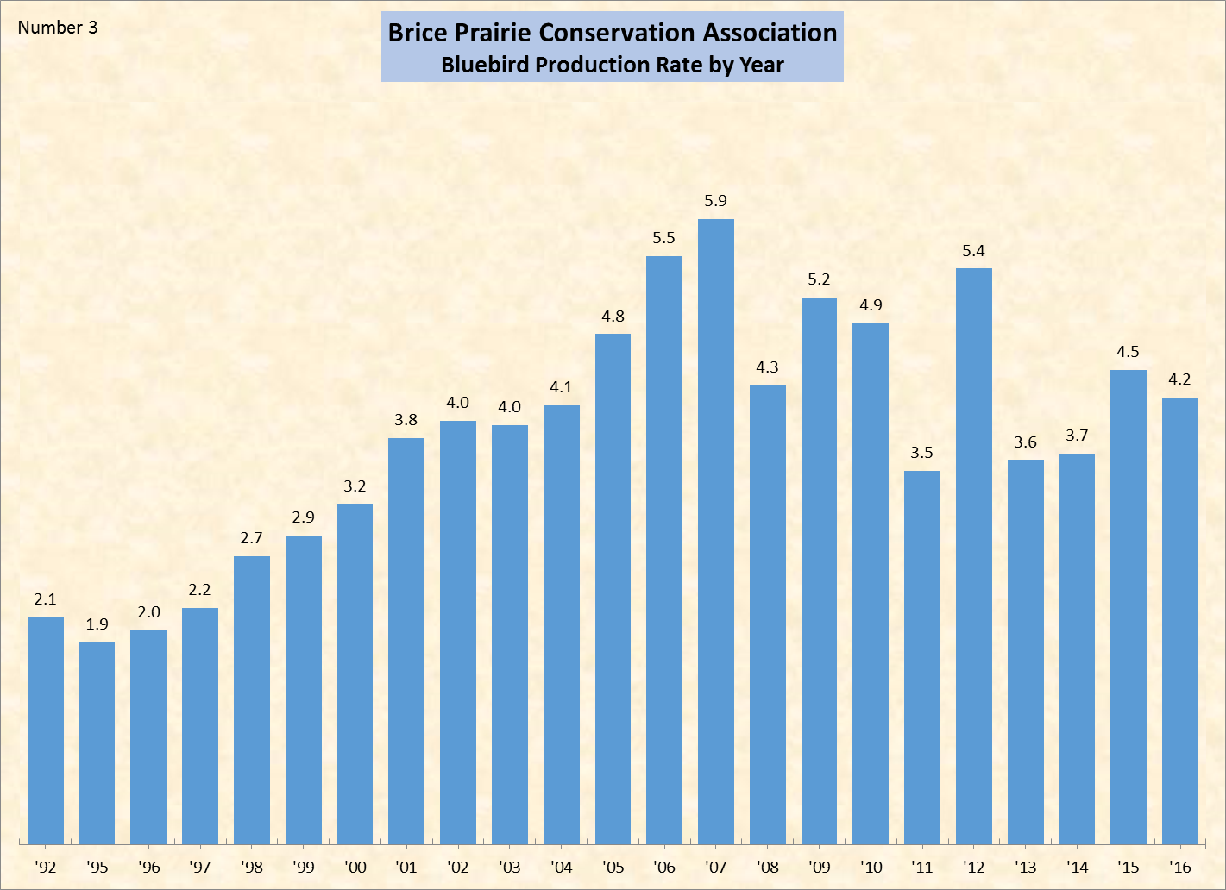

9

