Production of Eastern Bluebirds in Monitored Houses

Annual Report - 2012

Brice Prairie Conservation Association

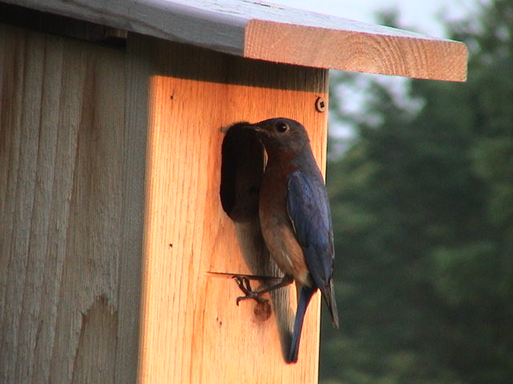

By

Leif L. Marking, Project Manager

W7917 CTH ZB
Onalaska, Wisconsin 54650
lcmarking@gmail.com
608-526-4885 or 608-781-0323

Production of Eastern Bluebirds in Monitored Houses

Introduction: Bluebirds are cavity-nesting songbirds that are unable to create their own nesting cavities. Natural cavity availability declined significantly when non-native House Sparrows and European Starlings were introduced to this country over 150 years ago because they were victorious competitors for nest cavities and vicious predators of bluebird eggs and young. However, bluebird populations have been increasing since the birth of the North American Bluebird Society (NABS) in 1978 followed by many state chapters such as the Bluebird Restoration Association of Wisconsin (BRAW). Our Brice Prairie Conservation Association (BPCA) members have recorded our bluebird production activities since 1992 and annually reported the numbers to the above organizations. Technical information and instructions for producing bluebirds are available from websites of NABS (www.nabluebirdsociety.org), BRAW (www.BRAW.org), and BPCA (www.briceprairieconservation.org). The purpose of this report is to summarize the numbers of bluebirds produced by club members this year, recognize increases or decreases over last year, identify problems that influenced production, and evaluate procedures to increase future production.

Procedures: We have selected the NABS-style house to promote bluebird production because the design is practical, they are easy to construct, maintain, and clean, and bluebirds readily occupy them. These cedar houses are mounted on 7-foot steel T-type fence posts that are covered with a 5 ft. section of PVC pipe (1 ½”) for mammalian predator control. The houses are usually placed 200 yards or more apart to respect the territorial nature of bluebirds and to encourage maximum production of bluebirds. New houses are built with convertible air vents, and vents are covered on existing houses to reduce mortality of eggs and young during sustained cold spells in early nesting and to prevent black fly mortality during second nesting. Site and habitat selection favors bluebird ecology with large, open, grazed or mowed areas where bluebirds can forage for insects. House Sparrow competition was diminished appreciably by avoiding active farm and livestock feeding operations. Houses were placed at least 200 feet from woods and thickets to minimize House Wren competition. Weekly observations were recorded in notebooks of choice, and those results were transferred to spreadsheets for calculations, evaluations, and presentations. These spreadsheets accumulate numbers of eggs, numbers hatched, and count of bluebirds and other cavity- nesting songbirds fledged. Finally, the numbers are consolidated for each member’s totals as well as individual and total production rates for all club members and bluebird associates.

2
Results and Discussion: We monitored 862 bluebird boxes this year, 74 fewer than last year. These boxes produced 4,679 bluebird fledglings, an increase of 1,385 compared to the previous year. Our bluebird production rate also increased this year to 5.4 fledglings per box, primarily due to the early spring season that favored early nesting activity and more third nesting later in the year than normal nesting seasons. Some nestling mortality was due to black fly gnat infestations. A dilute solution of Permethrin spray was used with good success to combat the black flies. Three heat cycles occurred in July when local temperatures peaked at 103 degrees or more and set new records for La Crosse County. Some monitors reported heat mortalities of nestlings and some eggs reportedly failed to hatch. Venting the boxes containing advanced nestlings offered better survival. Raccoon were recognized as a major ground predator. Car wax applied to the predator guard shows promise for prevention.

We also produced 547 Tree Swallows, 68 House Wrens, and 78 Black Capped Chickadees. These cavity nesting species readily occupy the bluebird boxes, especially if they are located on the edge of bluebird territory habitat. We have found that Tree Swallows may dominate boxes placed near adjoining wetlands, so we get some relief for the bluebirds by avoiding those areas. The bluebirds prefer diversified agriculture, mowed, or grazed areas, and if the boxes are properly located and spaced the bluebirds will occupy them before the swallows (serious competitors) are capable of nesting in early spring.

My 13 bluebird associates produced 892 bluebird fledglings, 84 Tree Swallows, and 35 chickadees as identified in the second table. These folks are not members of BPCA, but they like bluebirds and our technology for producing them, and they are willing to monitor and contribute to our efforts. Of course they realize their efforts also benefit the bluebird population so we are thankful. This associate concept encourages more people to get involved in serious monitoring and keeping good records. Five of the associates had bluebird production rates greater than 5.7.

We attribute our success for producing bluebirds to providing a box with a cavity size and shape that appeals to them, selection of ideal habitat for box location, spacing the boxes at least 200 yards, providing predator prevention for every box, moving boxes that fail to attract bluebirds after one year, and monitoring weekly to ensure the cavities are available to bluebirds that are searching for a home. House Sparrows interfered with bluebird nesting in limited locations, but wrens again were important predators and competitors on some bluebird trails. Our technology for bluebird production is effective, and we feel satisfied and rewarded with the bluebird responses to our efforts and look forward to their return next spring.

3

Consolidated Nest Box Summary 2012
Brice Prairie Conservation Association – Individuals

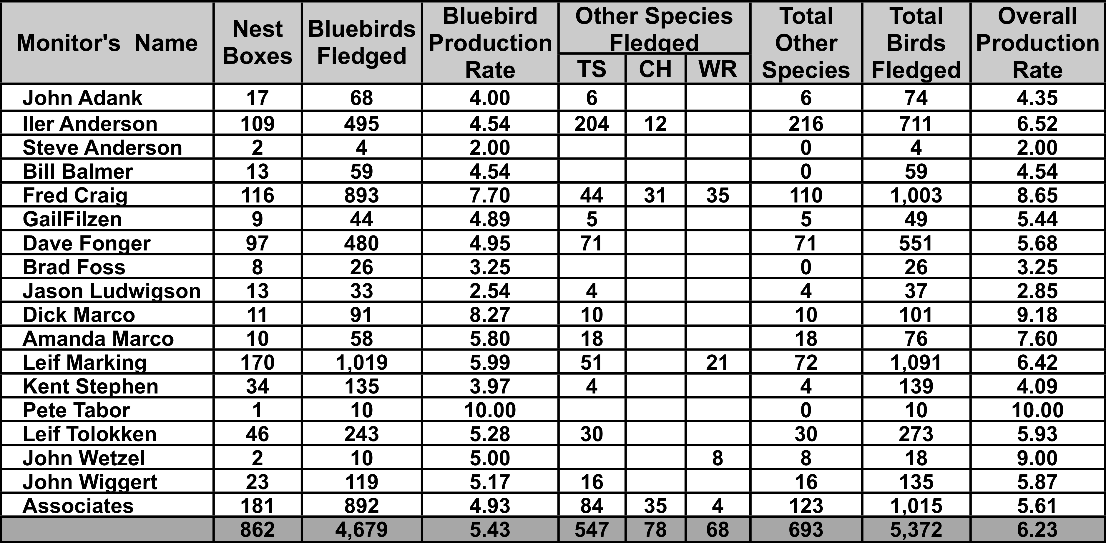
Species Key: TS - Tree Swallow, CH - Chickadee, WR – Wren

4

Consolidated Nest Box Summary 2012
Leif Marking Bluebird Associates

Associate's Name | Nest Boxes | Bluebirds Fledged | Bluebird Production Rate | Other Species Fledged |  |  | Total Other Species | Total Birds Fledged | Overall Production Rate
 |  |  |  | TS | CH | WR | Total Other Species | Total Birds Fledged | Overall Production Rate
Jan and Jim Brady | 10 | 81 | 8.10 | 11 |  |  | 11 | 92 | 9.20
Louis Benchina | 29 | 112 | 3.86 | 9 |  |  | 9 | 121 | 4.17
Harry & Ellen Caulum | 22 | 91 | 4.14 |  |  |  | 0 | 91 | 4.14
Verdel Dawson | 14 | 82 | 5.86 |  | 31 |  | 31 | 113 | 8.07
Jack and Joyce Ebert | 8 | 35 | 4.38 | 31 |  |  | 31 | 66 | 8.25
Lloyd Hoff | 7 | 26 | 3.71 |  |  |  | 0 | 26 | 3.71
Morgan Jostad | 14 | 83 | 5.93 |  | 4 |  | 4 | 87 | 6.21
Tim Knudson | 12 | 56 | 4.67 | 13 |  |  | 13 | 69 | 5.75
Stephanie Lubinsky | 14 | 81 | 5.79 | 7 |  | 3 | 10 | 91 | 6.50
John Leary | 9 | 28 | 3.11 |  |  |  | 0 | 28 | 3.11
Gordon Romskog | 19 | 119 | 6.26 | 6 |  | 1 | 7 | 126 | 6.63
Jean Ruhser | 9 | 35 | 3.89 | 3 |  |  | 3 | 38 | 4.22
Fred Shaldach | 14 | 63 | 4.50 | 4 |  |  | 4 | 67 | 4.79
 | 181 | 892 | 4.93 | 84 | 35 | 4 | 123 | 1,015 | 5.61

Species Key: TS - Tree Swallow, CH - Chickadee, WR - Wren

5

Bluebird Production in Houses of Different Types
Year | Number |  | Production  Rate | Predominant  House Type
Year | Houses | Fledged | Production  Rate | Predominant  House Type
1992 | 29 | 62 | 2.1 | Hill Lake
1995 | 42 | 80 | 1.9 | Hill Lake
1996 | 54 | 109 | 2.0 | Tree Branch
1997 | 65 | 145 | 2.2 | Tree Branch
1998 | 78 | 212 | 2.7 | Tree Branch
1999 | 91 | 265 | 2.9 | Herman Olson
2000 | 101 | 324 | 3.2 | Herman Olson
2001 | 142 | 544 | 3.8 | NABS
2002 | 285 | 1,138 | 4.0 | NABS
2003 | 506 | 2,001 | 4.0 | NABS
2004 | 741 | 3,066 | 4.1 | NABS
2005 | 880 | 4,233 | 4.8 | NABS
2006 | 858 | 4,756 | 5.5 | NABS
2007 | 916 | 5,399 | 5.9 | NABS
2008 | 977 | 4,228 | 4.3 | NABS
2009 | 1,019 | 5,252 | 5.2 | NABS
2010 | 1,001 | 4,915 | 4.9 | NABS
2011 | 936 | 3,294 | 3.5 | NABS
2012 | 862 | 4,679 | 5.4 | NABS
 | Total | 44,702

By Members of Brice Prairie Conservation Association

6

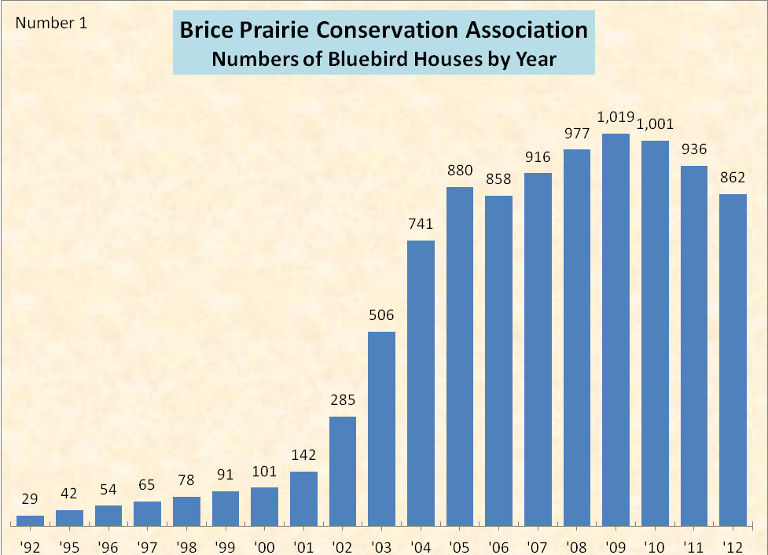

7

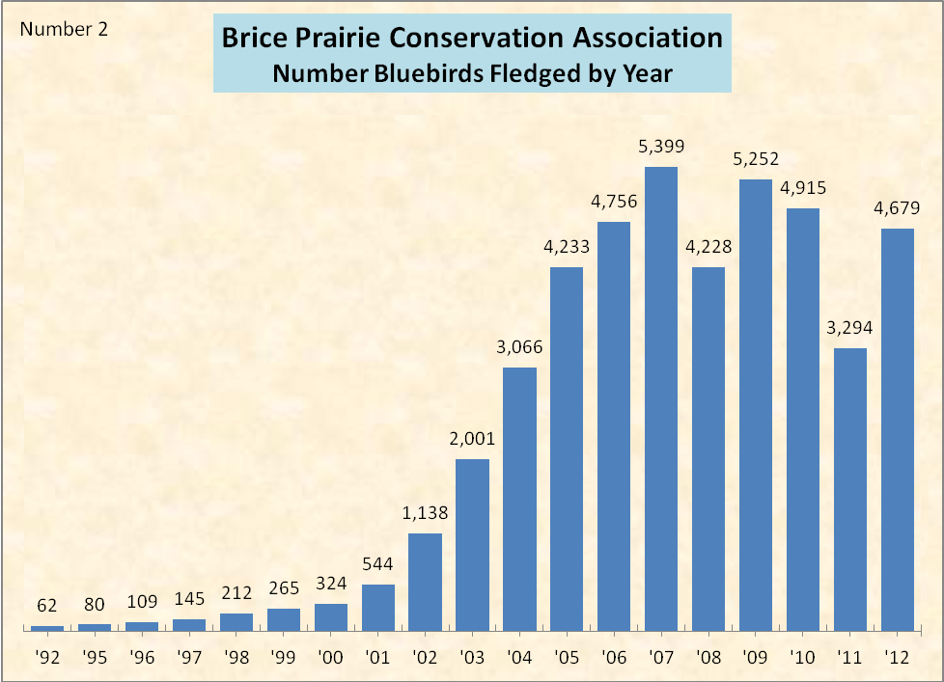

8

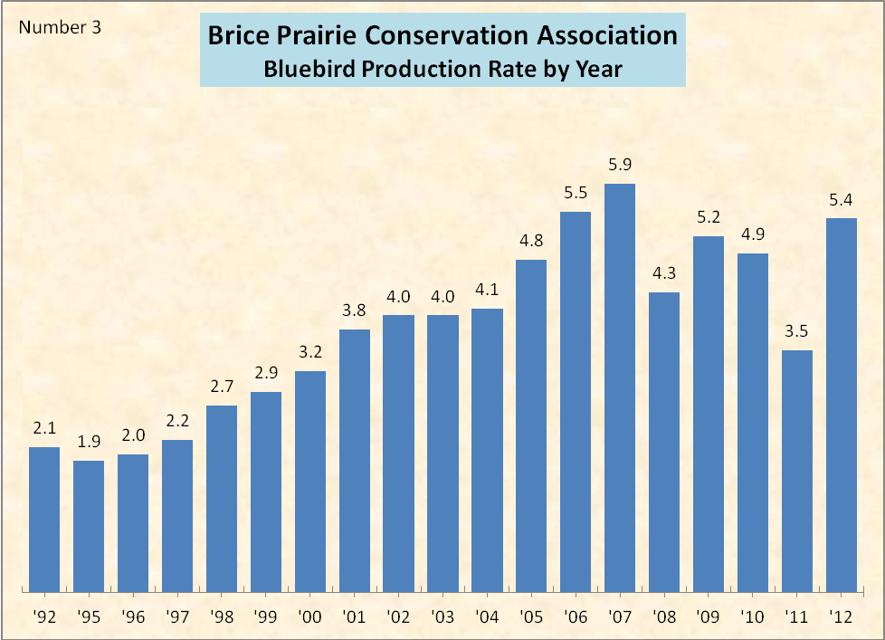

9

