Production of Eastern Bluebirds in Monitored Houses

Annual Report - 2011
Brice Prairie Conservation Association

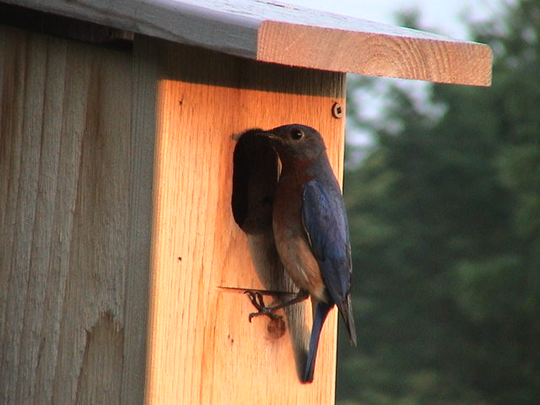

By
Leif L. Marking, Project Manager

W7917 CTH ZB
Onalaska, Wisconsin 54650
lcmarking@gmail.com
608-526-4885 or 608-781-0323

Production of Eastern Bluebirds in Monitored Houses

Introduction: Bluebirds are cavity-nesting songbirds that are unable to create their own nesting cavities. Natural cavity availability declined significantly when non-native House Sparrows and European Starlings were introduced to this country over 150 years ago because they were victorious competitors for nest cavities and vicious predators of bluebird eggs and young. However, bluebird populations have been increasing since the birth of the North American Bluebird Society (NABS) in 1978 followed by many state chapters such as the Bluebird Restoration Association of Wisconsin (BRAW). Our Brice Prairie Conservation Association (BPCA) members have recorded our bluebird production activities since 1992 and annually reported the numbers to the above organizations. Technical information and instructions for producing bluebirds are available from websites of NABS (www.nabluebirdsociety.org), BRAW (www.BRAW.org), and BPCA (www.briceprairieconservation.org). The purpose of this report is to summarize the numbers of bluebirds produced by club members this year, recognize increases or decreases over last year, identify problems that influenced production, and evaluate procedures to increase future production.

Procedures: We have selected the NABS-style house to promote bluebird production because the design is practical, they are easy to construct, maintain, and clean, and bluebirds readily occupy them. These cedar houses are mounted on 7-foot steel T-type fence posts that are covered with a 5 ft. section of PVC pipe (1 ½”) for mammalian predator control. The houses are usually placed 200 yards or more apart to respect the territorial nature of bluebirds and to encourage maximum production of bluebirds. New houses are built without air vents, and vents are covered on existing houses to reduce mortality of eggs and young during sustained cold spells in early nesting and to prevent black fly mortality during second nesting. Site and habitat selection favors bluebird ecology with large, open, grazed or mowed areas where bluebirds can forage for insects. House Sparrow competition was diminished appreciably by avoiding active farm and livestock feeding operations. Houses were placed at least 200 feet from woods and thickets to minimize House Wren competition. Weekly observations were recorded in notebooks of choice, and those results were transferred to spreadsheets for calculations, evaluations, and presentations. These spreadsheets accumulate numbers of eggs, numbers hatched, and count of bluebirds and other cavity- nesting songbirds fledged. Finally, the numbers are consolidated for each member’s totals as well as individual and total production rates for all club members and bluebird affiliates.

2

Results and Discussion: We monitored 936 bluebird boxes this year, 65 fewer than last year. These boxes produced 3,294 bluebird fledglings, a decrease of 1621 compared to the previous year. Our bluebird production rate also decreased this year to 3.5 fledglings per box, primarily due to cold and rainy weather in the early nesting season and severe nestling mortality due to black fly gnat infestations. Several cold periods in April delayed bluebird nesting activities. Those delays favored tree swallows using those boxes during the first nesting season. Then black flies destroyed hundreds of bluebird nestlings during June and July. Three heat cycles occurred in June and July when local temperatures peaked at 100 degrees or more, but few monitors reported heat mortalities. We are seeking methods to prevent black fly mortalities in the future.

We also produced 687 Tree Swallows, 268 House Wrens, and 34 Black Capped Chickadees. These cavity nesting species readily occupy the bluebird boxes, especially if they are located on the edge of bluebird territory habitat. We have found that Tree Swallows may dominate boxes placed near the Black River, La Crosse River, smaller streams and ponds, and adjoining wetlands in those areas, so we get some relief for the bluebirds by avoiding those areas. The bluebirds prefer diversified agriculture, mowed, or grazed areas, and if the boxes are properly located and spaced the bluebirds will occupy them before the swallows (serious competitors) are capable of nesting in early spring.

My 13 bluebird associates produced 541 bluebird fledglings, 113 Tree Swallows, and 76 wrens as identified in the second table. These folks are not members of BPCA, but they like bluebirds and our technology for producing them, and they are willing to monitor and contribute to our efforts. Of course they realize their efforts also benefit the bluebird population so we are thankful. This associate concept encourages more people to get involved in serious monitoring and keeping good records. Three of the associates had bluebird production rates of 5.0 or above.

We attribute our success for producing bluebirds to providing a box with a cavity size and shape that appeals to them, selection of ideal habitat for box location, spacing the boxes at least 200 yards, providing predator prevention for every box, moving boxes that fail to attract bluebirds after one year, and monitoring weekly to ensure the cavities are available to bluebirds that are searching for a home. House Sparrows interfered with bluebird nesting in limited locations, but wrens again were the most important predator and competitor on our bluebird trails. Our technology for bluebird production is effective, and we feel satisfied and rewarded with the bluebird responses to our efforts and look forward to their return next spring.

3
Consolidated Nest Box Summary 2011
Brice Prairie Conservation Association – Individuals

Monitor's Name | Nest Boxes | Bluebirds Fledged | Bluebird Production Rate | Other Species Fledged |  |  | Total Other Species | Total Birds Fledged | Overall Production Rate
 |  |  |  | TS | CH | WR | Total Other Species | Total Birds Fledged | Overall Production Rate
John Adank | 20 | 56 | 2.80 |  |  |  |  | 56 | 2.80
Iler Anderson | 113 | 456 | 4.04 | 178 | 16 |  | 194 | 650 | 5.75
Steve Anderson | 1 | 4 | 4.00 |  |  |  | 0 | 4 | 4.00
Bill Balmer | 12 | 24 | 2.00 | 6 | 15 |  | 21 | 45 | 3.75
Fred Craig | 144 | 711 | 4.94 | 87 | 3 | 94 | 184 | 895 | 6.22
Gail Filzen | 10 | 34 | 3.40 | 7 |  |  | 7 | 41 | 4.10
Dave Fonger | 138 | 366 | 2.65 | 194 |  | 26 | 220 | 586 | 4.25
Brad Foss | 8 | 35 | 4.38 |  |  |  | 0 | 35 | 4.38
Jason Ludwigson | 13 | 33 | 2.54 | 5 |  |  | 5 | 38 | 2.92
Dick Marco | 16 | 86 | 5.38 | 5 |  |  | 5 | 91 | 5.69
Amanda Marco | 13 | 44 | 3.38 | 14 |  |  | 0 | 44 | 3.38
Leif Marking | 172 | 594 | 3.45 | 24 |  | 37 | 61 | 655 | 3.81
John Smith | 12 | 36 | 3.00 | 14 |  | 8 | 22 | 58 | 4.83
Kent Stephen | 36 | 77 | 2.14 | 4 |  |  | 4 | 81 | 2.25
Pete Tabor | 1 | 5 | 5.00 |  |  |  | 0 | 5 | 5.00
Leif Tolokken | 23 | 114 | 4.96 | 19 |  |  | 19 | 133 | 5.78
John Wiggert | 23 | 78 | 3.39 | 17 |  | 27 | 44 | 122 | 5.30
Associates | 181 | 541 | 2.99 | 113 |  | 76 | 189 | 730 | 4.03
 | 936 | 3,294 | 3.52 | 687 | 34 | 268 | 975 | 4,269 | 4.56

Species Key: TS - Tree Swallow, CH - Chickadee, WR – Wren

4

Consolidated Nest Box Summary 2011
Leif Marking Associate Bluebirders
Monitor's Name | Nest Boxes | Bluebirds Fledged | Bluebird Production Rate | Other Species Fledged |  |  | Total Other Species | Total Birds Fledged | Overall Production Rate
 |  |  |  | TS | CH | WR | Total Other Species | Total Birds Fledged | Overall Production Rate
Jan/Jim Brady | 10 | 55 | 5.50 | 14 |  |  | 14 | 69 | 6.90
Louis Benchina | 14 | 19 | 1.36 | 4 |  |  | 4 | 23 | 1.64
Harry/Ellen Caulum | 22 | 81 | 3.68 |  |  | 34 | 34 | 115 | 5.23
Verdel Dawson | 12 | 55 | 4.58 |  |  |  | 0 | 55 | 4.58
Kathryn Engber | 6 | 16 | 2.67 | 3 |  |  | 3 | 19 | 3.17
Lloyd Hoff | 7 | 15 | 2.14 |  |  |  | 0 | 15 | 2.14
Morgan Jostad | 13 | 42 | 3.23 | 10 |  |  | 10 | 52 | 4.00
Tim Knudson | 13 | 29 | 2.23 | 23 |  |  | 23 | 52 | 4.00
John Leary | 10 | 4 | 0.40 | 4 |  |  | 4 | 8 | 0.80
Gordon Romskog | 24 | 71 | 2.96 | 20 |  | 37 | 57 | 128 | 5.33
Jean Ruhser | 9 | 25 | 2.76 |  |  |  | 0 | 25 | 2.78
Fred Sheldach | 16 | 64 | 4.00 | 5 |  |  | 5 | 69 | 4.31
Charlie Ustby | 25 | 65 | 2.60 | 30 |  | 5 | 35 | 100 | 4.00
 | 181 | 541 | 2.99 | 113 | 0 | 76 | 189 | 730 | 4.03

Species Key: TS - Tree Swallow, CH - Chickadee, WR - Wren

5

Bluebird Production in Houses of Different Types
Year | Number |  | Production  Rate | Predominant  House Type
Year | Houses | Fledged | Production  Rate | Predominant  House Type
1992 | 29 | 62 | 2.1 | Hill Lake
1995 | 42 | 80 | 1.9 | Hill Lake
1996 | 54 | 109 | 2.0 | Tree Branch
1997 | 65 | 145 | 2.2 | Tree Branch
1998 | 78 | 212 | 2.7 | Tree Branch
1999 | 91 | 265 | 2.9 | Herman Olson
2000 | 101 | 324 | 3.2 | Herman Olson
2001 | 142 | 544 | 3.8 | NABS
2002 | 285 | 1,138 | 4.0 | NABS
2003 | 506 | 2,001 | 4.0 | NABS
2004 | 741 | 3,066 | 4.1 | NABS
2005 | 880 | 4,233 | 4.8 | NABS
2006 | 858 | 4,756 | 5.5 | NABS
2007 | 916 | 5,399 | 5.9 | NABS
2008 | 977 | 4,228 | 4.3 | NABS
2009 | 1,019 | 5,252 | 5.2 | NABS
2010 | 1,001 | 4,915 | 4.9 | NABS
2011 | 936 | 3,294 | 3.5 | NABS
 | Total | 40,023
By Members of Brice Prairie Conservation Association

6

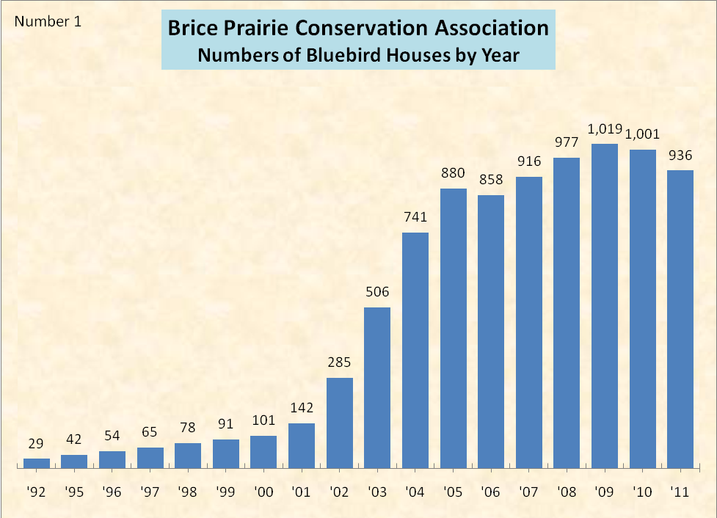

7
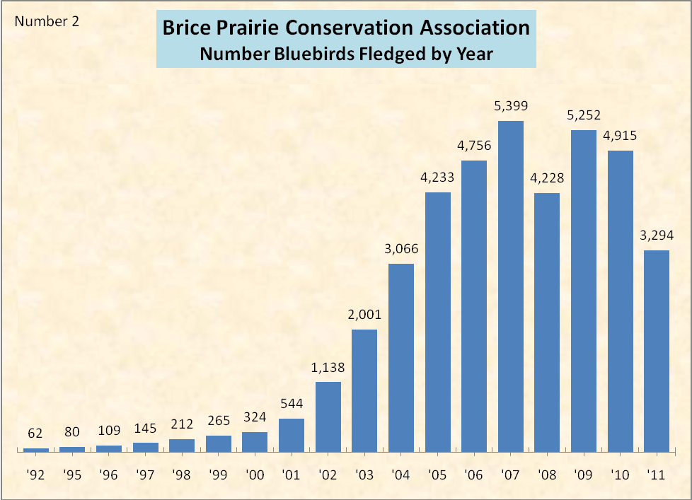

8

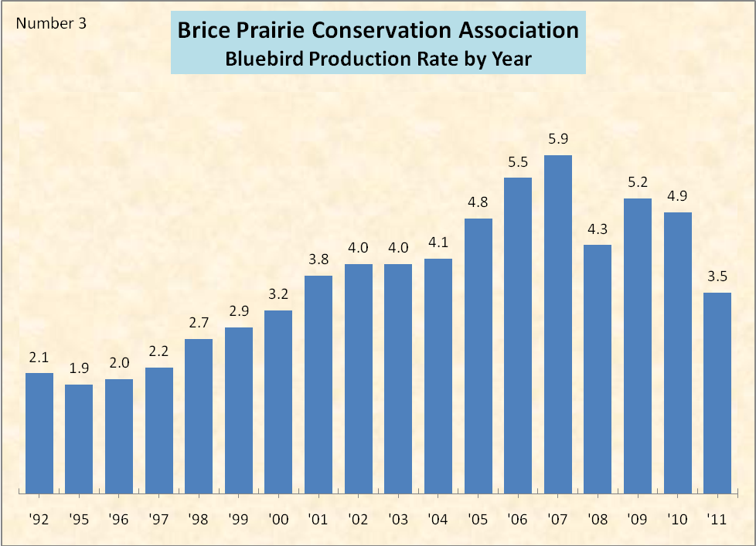

9

