Production of Bluebirds in Monitored Houses

Annual Report - 2003
Brice Prairie Conservation Association

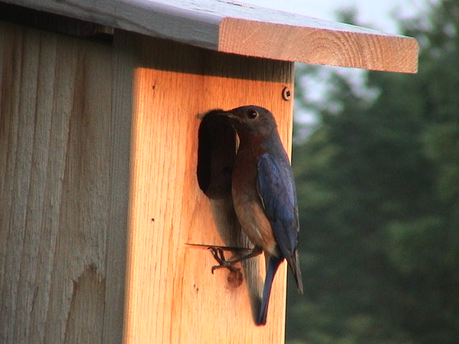

By
Leif L. Marking, Project Manager

W7917 CTH ZB
Onalaska, Wisconsin 54650
cmarking@centurytel.net
(608) 781-0323

Production of Bluebirds in Monitored Houses

Summary of Results for 2003

Bluebirds are cavity nesting song birds that are unable to create their own nesting cavities. Natural cavity availability declined significantly when non-native house sparrows and European starlings were introduced to this country because they were predators and competitors of bluebird eggs, young, and nest sites. However, bluebird populations have been increasing since the birth of the North American Bluebird Society (NABS) in 1978 followed by many state chapters. Our Brice Prairie Conservations Association (BPCA) members have selected the NABS style house to promote bluebird production because the design is so practical, they are easy to construct, and bluebirds readily occupy them (http://www.nabluebirdsociety.org/e_wbox2.htm). We mount these cedar houses on a steel T-type fence post that is covered with a 5 ft. section of PVC pipe (1 ½”) for mammalian predator control. The houses are placed 200 yards or more apart to respect the territorial nature of bluebirds and to obtain maximum production of bluebirds. Site and habitat selection favors bluebird ecology with large open grazed or mowed spaces where bluebirds forage for insects. Weekly observations are recorded in notebooks of choice and these results are transferred to spread sheet summaries for calculations, evaluations, and presentations.

Our BPCA goal was to produce 1,500 fledgling bluebirds in 2003 after recording 1,138 in 2002. We exceeded our goal by reporting 2,001 bluebirds, a new and exciting record for us. In addition we produced 395 tree swallows, 46 chickadees, and 14 wrens. This spectacular increase resulted from placing over 200 new houses, recruiting several bluebird trail masters, and by members moving problem houses to more conducive locations. Predation by wild animals was non-existent for 505 houses, but a house cat captured 5 young bluebirds at the Neshonoc Cemetery. There was no apparent mortality from heat, cold, or insects; but some mortality remained unexplained. House sparrows interfered with bluebird nesting in limited locations, but wrens again destroyed well over 100 bluebird eggs and young. Our most important indication of success was the bluebird production rate of 4.0 bluebirds per nest box and 4.9 of all species.

Production of Bluebirds by members of Brice Prairie Conservation Association

Consolidated Nest Box Summary - 2003

 |  |  | Bluebird | Other Species Fledged |  |  |  |  | Total | Total | Overall
Monitor's  Name | Nest Boxes | Bluebirds Fledged | Production Rate | TS | CH | WR | Other |  | Other Species | Birds Fledged | Production Rate
Iler Anderson | 40 | 167 | 4.18 | 72 |  |  |  |  | 72 | 239 | 5.98
Steve Anderson | 1 | 4 | 4.00 |  |  |  |  |  | 0 | 4 | 4.00
Bill Balmer | 35 | 76 | 2.17 | 23 | 28 |  |  |  | 51 | 127 | 3.63
Fred Craig | 114 | 575 | 5.04 | 75 | 11 |  |  |  | 86 | 661 | 5.80
Dave Fonger | 17 | 72 | 4.24 | 17 |  |  |  |  | 17 | 89 | 5.24
Skip Klein | 10 | 26 | 2.60 |  |  |  |  |  | 0 | 26 | 2.60
Dick Marco | 25 | 58 | 2.32 | 48 |  |  |  |  | 48 | 106 | 4.24
Greg Marco | 4 | 11 | 2.75 |  |  |  |  |  | 0 | 11 | 2.75
Leif Marking | 169 | 733 | 4.34 | 100 | 7 | 10 |  |  | 117 | 850 | 5.03
Ron Page | 3 | 7 | 2.33 |  |  |  |  |  | 0 | 7 | 2.33
Dave Skaloda | 9 | 13 | 1.44 | 9 |  | 4 |  |  | 13 | 26 | 2.89
Kent Stephan | 11 | 50 | 4.55 | 18 |  |  |  |  | 18 | 68 | 6.18
Leif Tolokken | 59 | 185 | 3.14 | 28 |  |  |  |  | 28 | 213 | 3.61
John Wiggert | 9 | 24 | 2.67 | 5 |  |  |  |  | 5 | 29 | 3.22
 | 506 | 2,001 | 3.95 | 395 | 46 | 14 | 0 |  | 455 | 2,456 | 4.85

Species Key: TS - Tree Swallow, CH - Chickadee, WR - Wren

