Production of Bluebirds in Monitored Houses

Annual Report - 2002
Brice Prairie Conservation Association

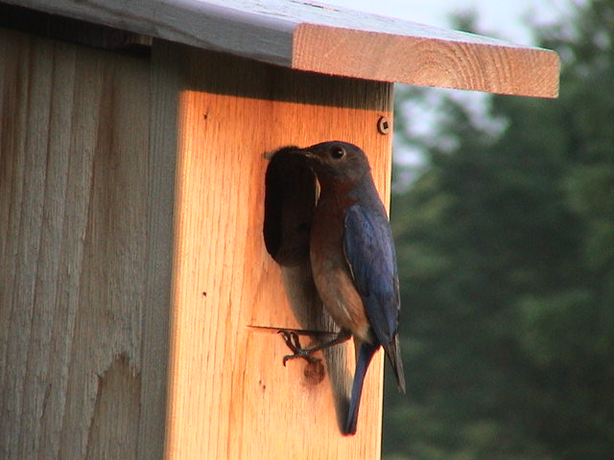

By

Leif L. Marking, Project Manager

W7917 CTH ZB
Onalaska, Wisconsin 54650
cmarking@centurytel.net
(608) 781-0323

Production of Bluebirds in Monitored Houses

Introduction

Bluebirds are cavity nesting songbirds but they are unable to create their own nesting cavities. In years past they have used natural cavities in trees and wooden fenceposts that were usually created by woodpeckers. Bluebird populations suffered a decline due to competition for natural and man-made nesting cavities with two non-native species, house sparrows and European starlings. In recent years human intervention has aided the recovery of bluebird populations, primarily through dedicated nest box programs that reduced impacts of avian and mammalian competition and predation. Now bluebirds are seen with increasing frequency, thanks to thousands of people who derive personal satisfaction from helping this beautiful bird to recover.

The primary reason for bluebird population recovery was the formation of organized groups starting with the North American Bluebird Society (NABS) in 1978. Since that time a number of state chapters have organized in the Midwest, originating with the Minnesota Bluebird Recovery Program. The Bluebird Restoration Association of Wisconsin (BRAW) and the Iowa Bluebird Program began their statewide programs in 1986, and other states have followed. Through these organized programs thousands of people have become infected with bluebird enthusiasm and have committed small but important parts of their lives to learning, understanding, promoting and appreciating this wonderful native bird that needs our help.

Methods & Materials

Information on different house types, creating trails, monitoring, predator prevention, and reporting data is readily available from organizations such as NABS and BRAW. Our Brice Prairie Conservation Association (BPCA) members have used different types of house plans in the past with moderate to good results. We have discovered that bluebirds did not prefer the deep Hill Lake houses during three years of monitoring. The newer Modified Tree Branch style is definitely raccoon proof but not preferred by bluebirds. The Peterson house is preferred by bluebirds but is space-limited, cumbersome, impractical to build, and needs more support for mounting. Our recent experiences suggest the NABS style house with a 4” x 5” bottom dimensions with the bottom placed 4” from the entry hole has been preferred by adult bluebirds, and the youngsters have ample room to grow and develop even with clutches of five or six. The NABS style house is easily built because the design is so practical. Plans for the house can be found at www.nabluebirdsociety.org/e_wbox2.htm.

We suggest people starting a bluebird trail use a house type they are comfortable with and one that produces results and satisfaction. Placement of houses in desirable bluebird habitat is essential for successful reproduction. Also, the mounting system should include protection from predators. Recommendations from NABS and BRAW include the use of PVC pipe over a steel T-type fence post as used in farmers’ fences. BPCA members use a 5’ x 1.5” PVC pipe over the steel post and have experienced little or no predation from raccoons and other ground predators. Houses are mounted to the PVC over the T-posts with a u-bolt to yield a firm and steady mount (Figure 1). Total cost of this substantial mounting system is about $5.00 per house.

The BPCA purchases cedar lumber for house construction and members construct the houses as needed. Each member numbers his/her houses and monitors them weekly to record nest building, eggs laid, eggs hatched, and young fledged. These results are given to the Project Manager for summarization at the end of each nesting season.

Site and habitat selection comes with experience, and we have discovered how to make our houses yield maximum production. Houses are never painted and usually placed 200 yards or more apart. Mowed and pastured areas are always desirable for good bluebird reproduction habitat.

Success is credited, not only by total numbers, but a simple Production Rate is calculated for the data from each member. This value is derived by dividing the total number of bluebirds produced by the total number of all houses placed, including those unused or with other species. This method is useful for a member to compare success of newly placed houses and seasoned houses or to compare one trail result to another. These values are very useful to compare year-to-year production success, and to set goals to be achieved by moving houses or adding new ones.

Weekly observations are recorded in notebooks of choice with a single page reserved for each house. When nesting is completed, the recordings are then transferred to a nest box summary form (See attachment A). This information is then easily transferred to NABS or BRAW summary forms. If more than two nestings occur in a single house, the additional nestings are recorded on new lines with the same house designation.

Results and Discussion

This was an excellent year for bluebird production in La Crosse County of Wisconsin. The long cool spell in spring favored bluebird nesting, but the colder temperatures deterred the tree swallows from their normal competition for nest boxes. Our production more than doubled that of last year (544 fledged) and tripled that of year 2000 (324), although several members placed more houses. Our goal was to produce more than 1,000 bluebirds in La Crosse County, and we surpassed the goal, respectively (See Table 1). Predation this year was minimal concerning mammals; only two houses were known to be attacked by raccoons. The PVC predator guard seems to be very effective in deterring most mammals.

Wrens were by far the major predators in our houses; they destroyed conservatively over 100 eggs or young of bluebirds. Most of our nest site selections do not favor wrens, but wrens have a tendency to patrol large areas that include open meadows, pastures, and mowed areas. The first nesting produced 30-50% more eggs than the second nesting. Presumably, wrens did not arrive in time to impact the first nesting, but they adversely impacted the second nesting. If wren predation occurs, the houses are usually moved the following year to avoid such predation a second time.

House sparrows interfered with bluebird nesting for some members, especially those with houses close to farmsteads where sparrows thrive. Since house sparrows are non-native and unprotected they can be eliminated from bluebird houses by various trapping devices that are available. Bluebirds are unable to defend their young against house sparrows and unable to take over a nest box that is occupied by house sparrows.

The Bluebird Nest Box Summary form was developed to summarize nesting information so members can easily compare annual production of their own and other members. Microsoft’s Excel program was used to create this nest box summary form.. Each Bluebird Nest Box Summary form calculates a production rate for all entries on that sheet. If more than 25 houses are being monitored, then additional summary sheets are used to summarize those houses.

Table 1 – Bluebird production by members of Brice Prairie Conservation Association

Name | Number of Houses | Eggs Produced | Eggs Hatched | Number Fledged | Production Rate
Bill Balmer | 31 | 96 | 89 | 87 | 2.8
Fred Craig | 103 | 552 | 469 | 452 | 4.4
Dave Fonger | 12 | 54 | 52 | 52 | 4.3
Brad Foss | 2 | 4 | 3 | 3 | 1.5
Skip Klein | 5 | 19 | 19 | 19 | 3.8
Greg Marco | 1 | 3 | 2 | 2 | 2.0
Leif Marking | 107 | 581 | 494 | 459 | 4.3
Ron Page | 2 | 12 | 11 | 7 | 3.5
Leif Tollokken | 10 | 29 | 28 | 25 | 2.5
John Wetzel | 2 | 10 | 7 | 7 | 3.5
John Wiggert | 10 | 40 | 25 | 25 | 2.5
Total | 285 | 1,400 | 1,199 | 1,138 | 4.0

Figure 1 – NABS style bluebird house showing mount with PVC predator guard and perch.

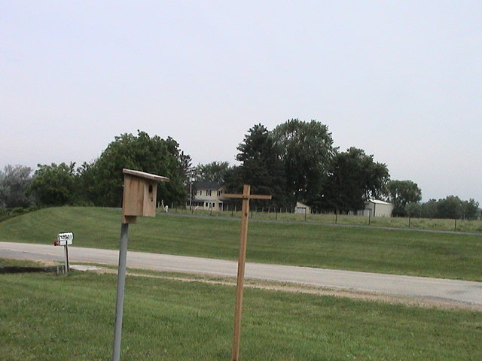

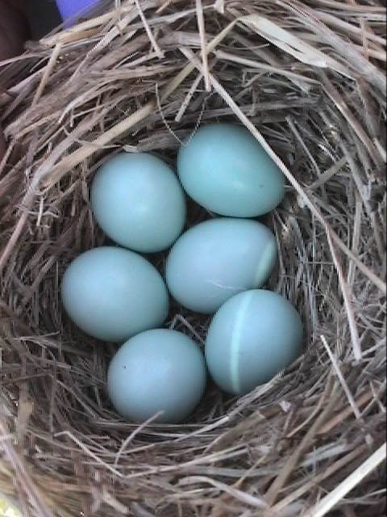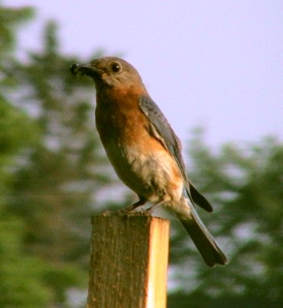
Bluebird Miracles Mother Superior

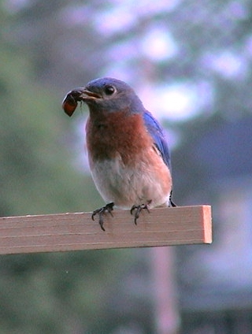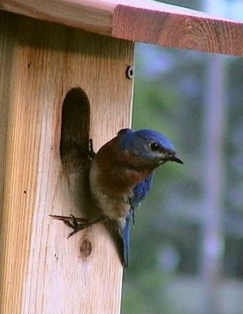
Master Provider Traction!

Attachment A

Bluebird Nest Box Summary Form

Brice Prairie Conservation Association

Monitor: ___________ Location Description: ___________________ Year: ______

House |  | First Nesting |  |  |  | Second Nesting |  |  |  | Specie Total
Number | Type | Species | Laid | Hatched | Fledged | Species | Laid | Hatched | Fledged | Bluebird | Other
1 | NABS | BB | 4 | 4 | 4 | TS | 5 | 4 | 4 | 4 | 4
2 | NABS | BB | 5 | 5 | 5 | BB | 4 | 4 | 0 | 5 | 0
3 | NABS | BB | 4 | 4 | 4 |  |  |  |  | 4 | 0
4 | NABS | None
 |  | Totals | 13 | 13 | 13 | Totals | 9 | 8 | 4 | 13 | 4

Total Houses: 4 Production Rate: 3.25

